**Tigergraph Certification**

**Tigergraph Fundamentals**

**Module 1 – Introduction to Graph Database and Analytics**

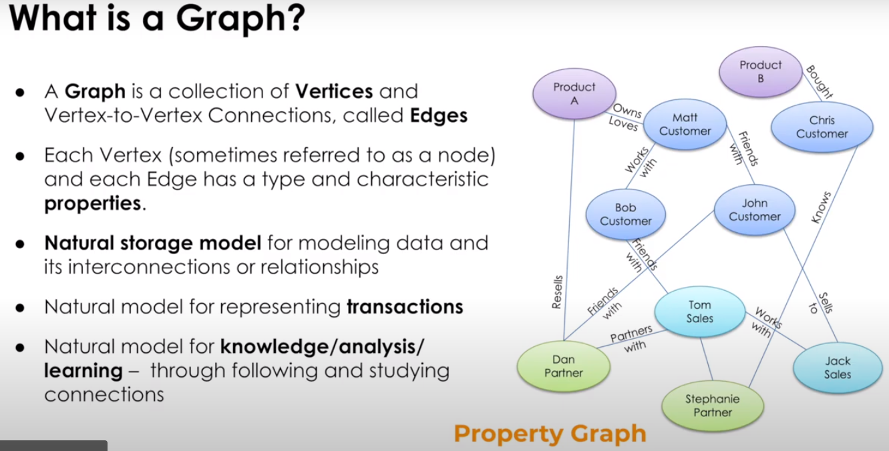

Vertices (Nodes) and Connections (Edges)

Each vertex and edge can have properties

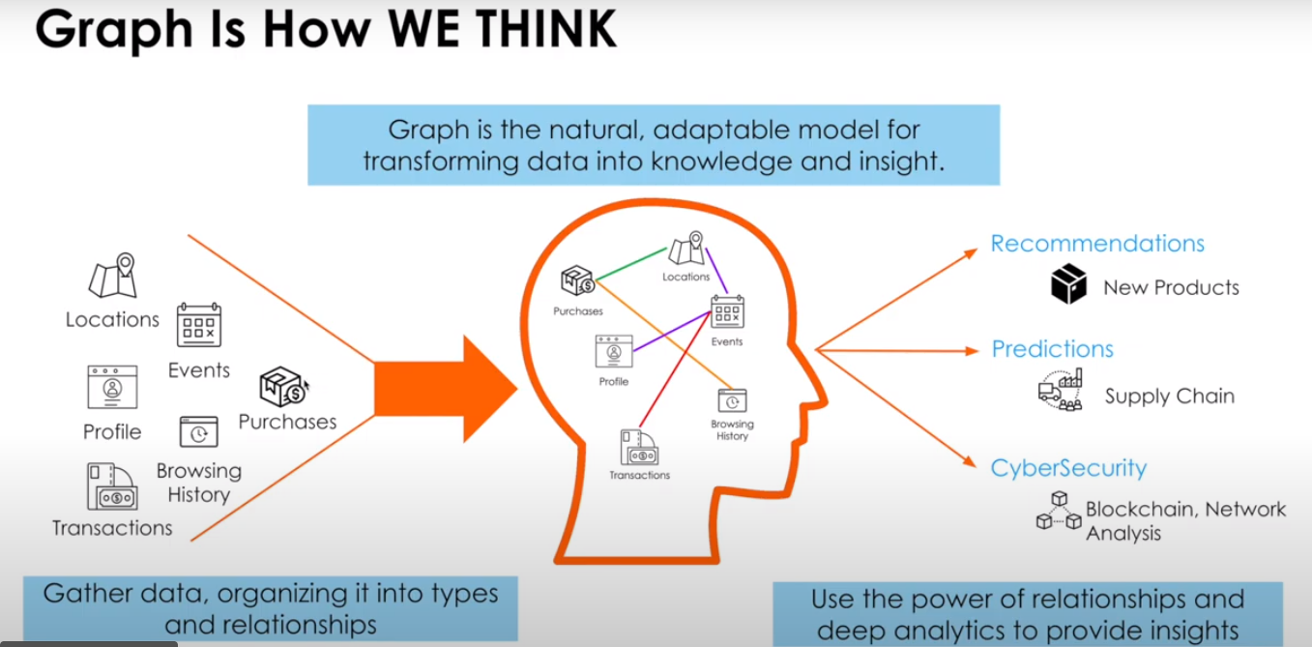

The logical model *is* the physical model

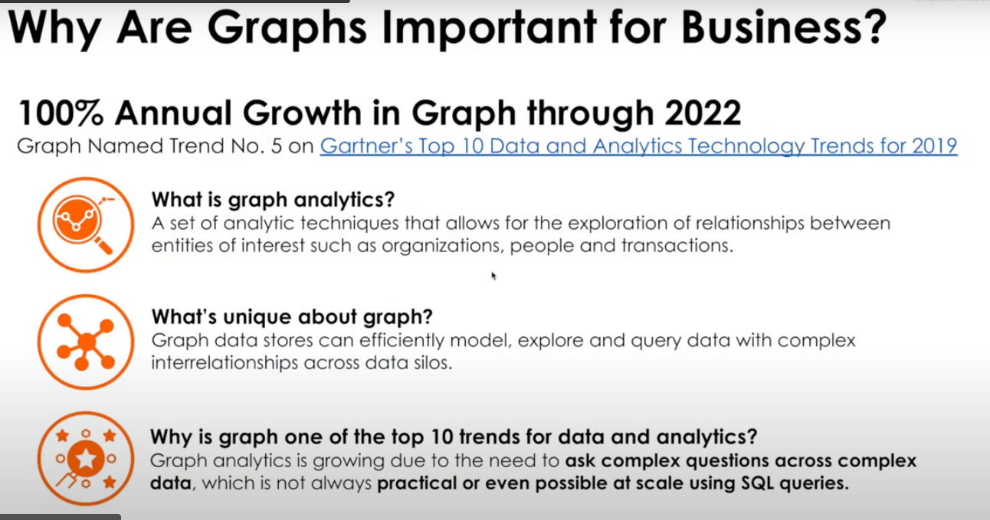

Deep exploration of relationships between entities

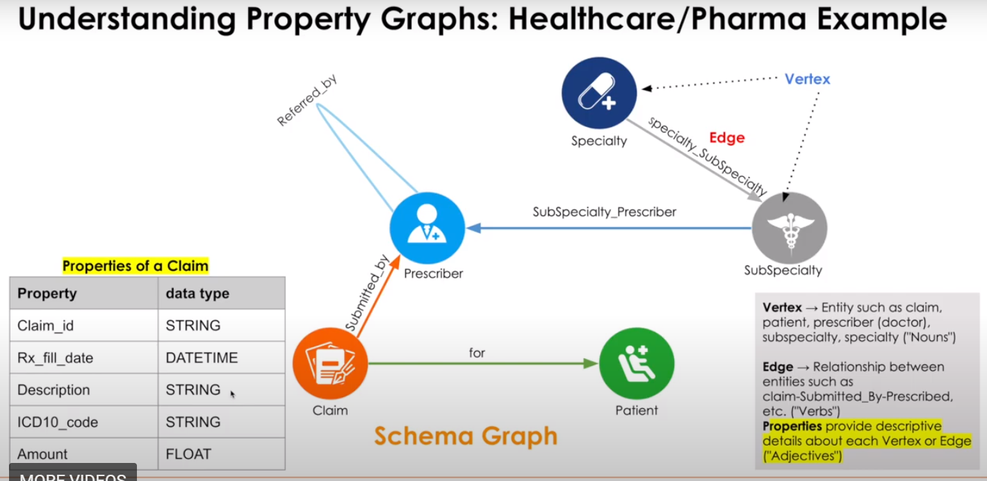

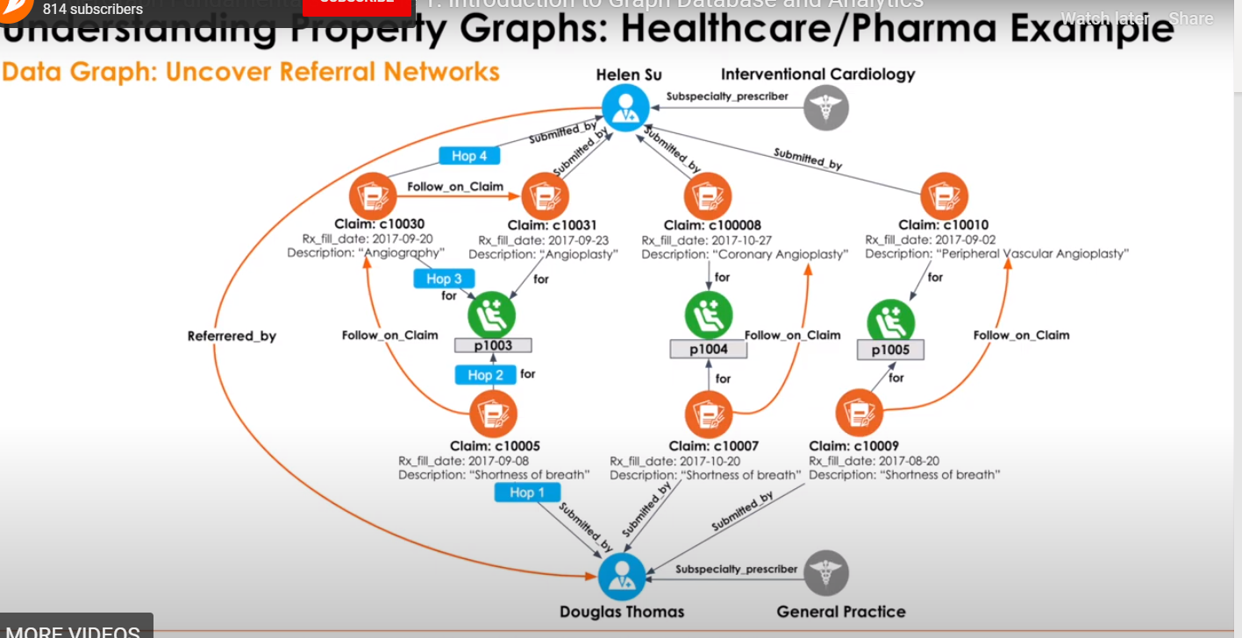

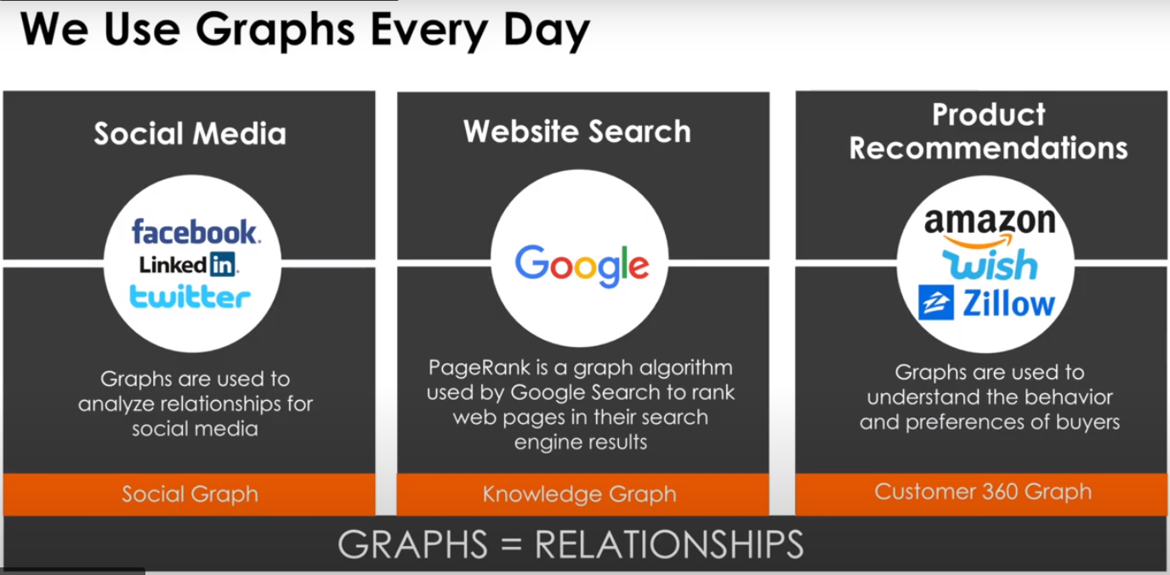

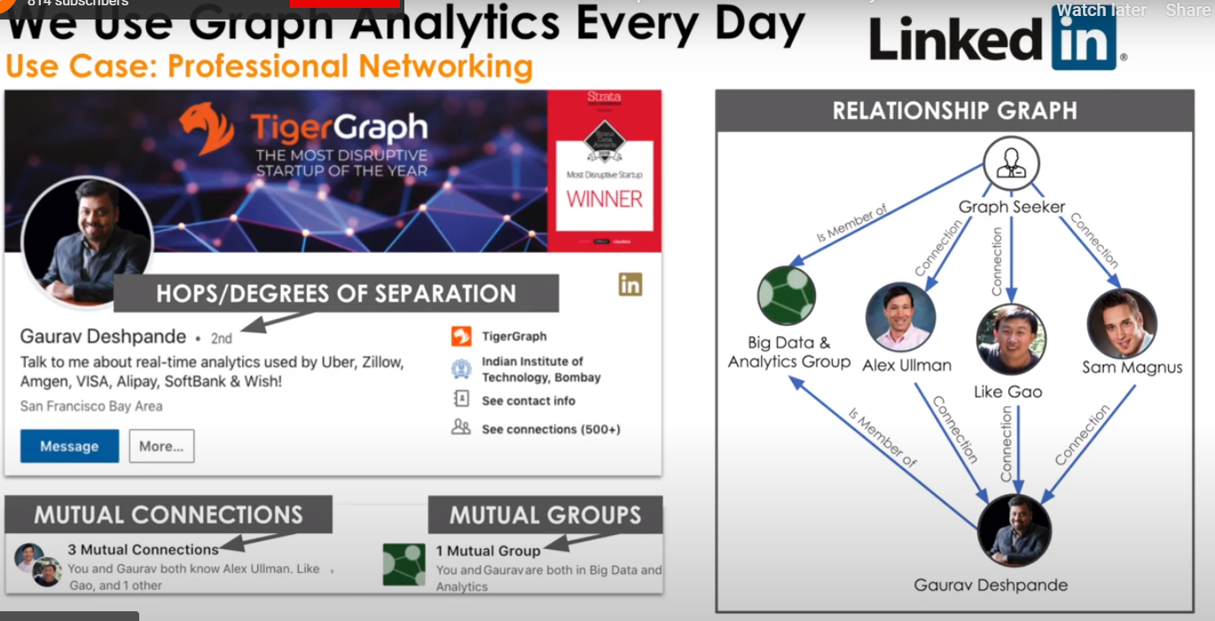

Number of hops

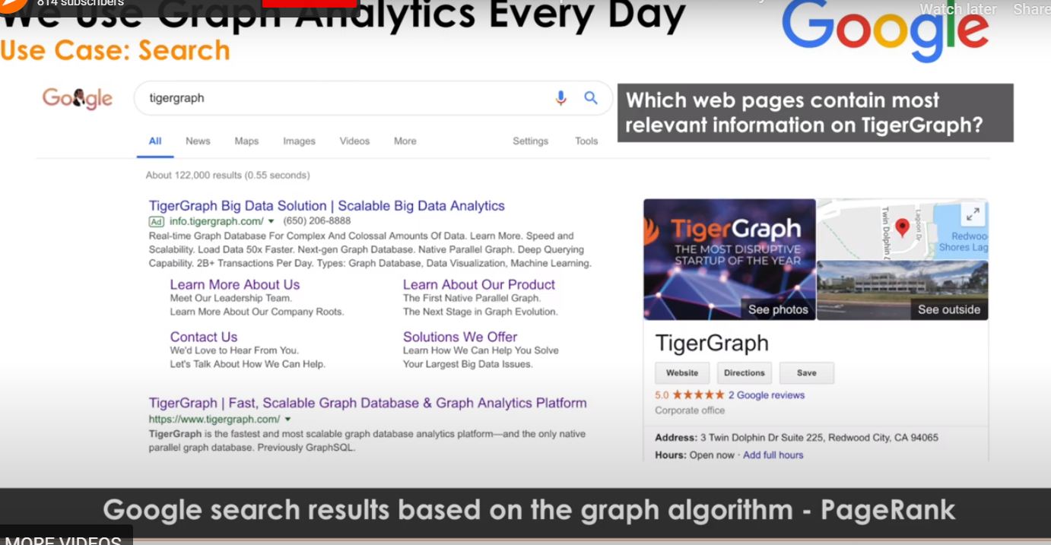

PageRank

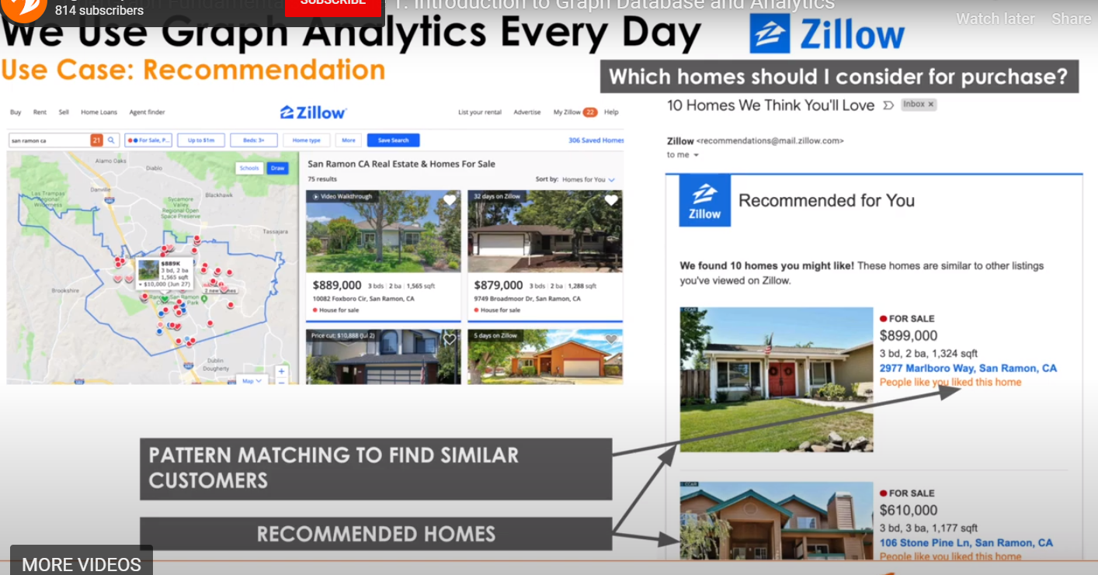

Similarity Search (Pattern matching)

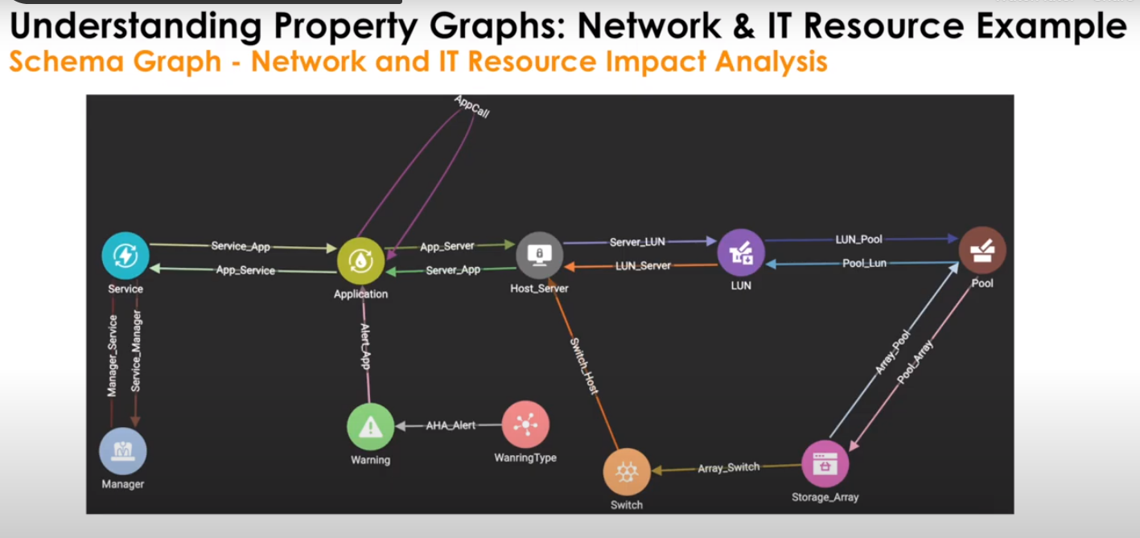

Network and IT Resource optimization through impact analysis

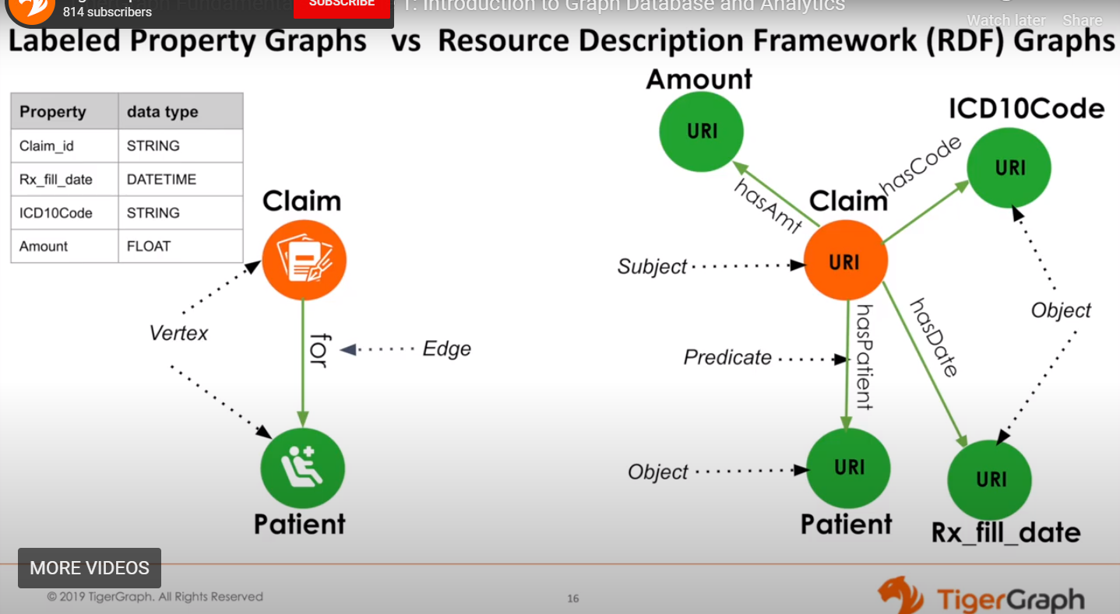

RDFs (subject, object, predicate) subjects and objects cannot carry any attribute  
Came about by a semantic web movement. They are very verbose. Graph query language is different. SparkQL is the standard.

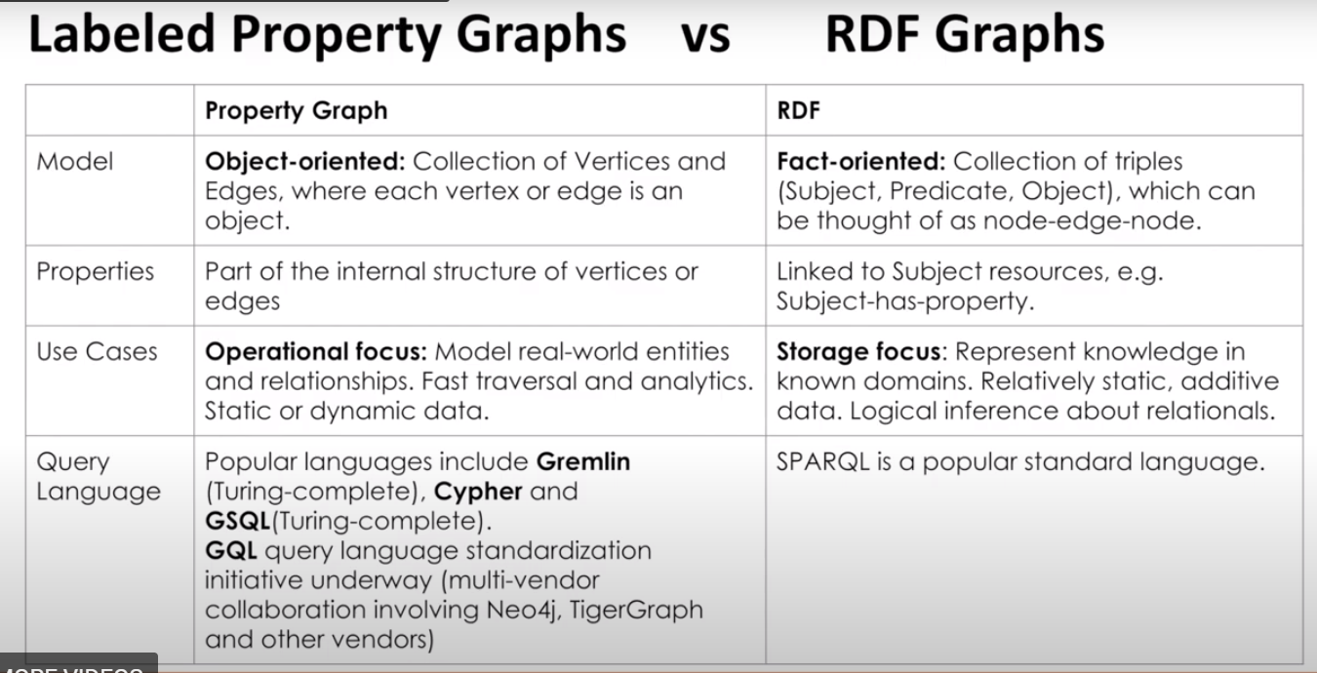

No standard query standard for   
New standard being worked on is GQL

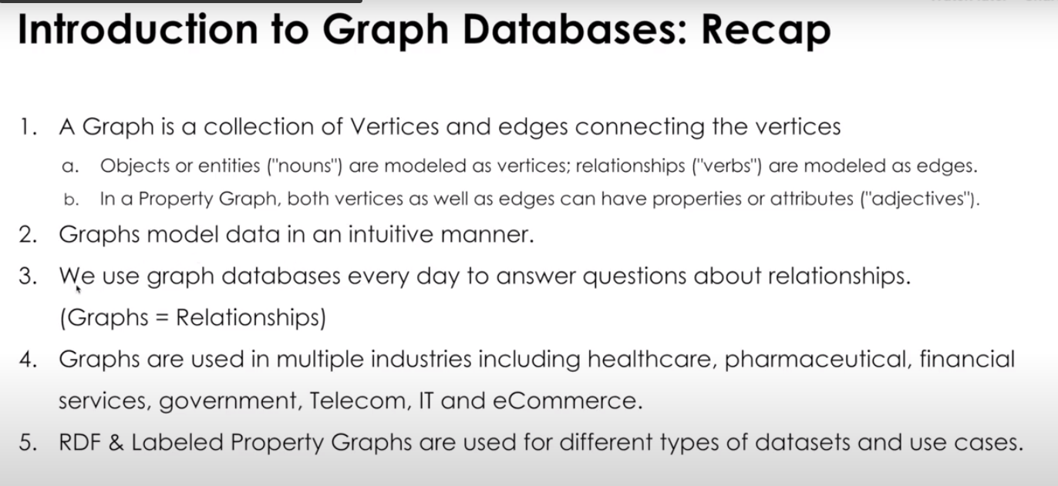

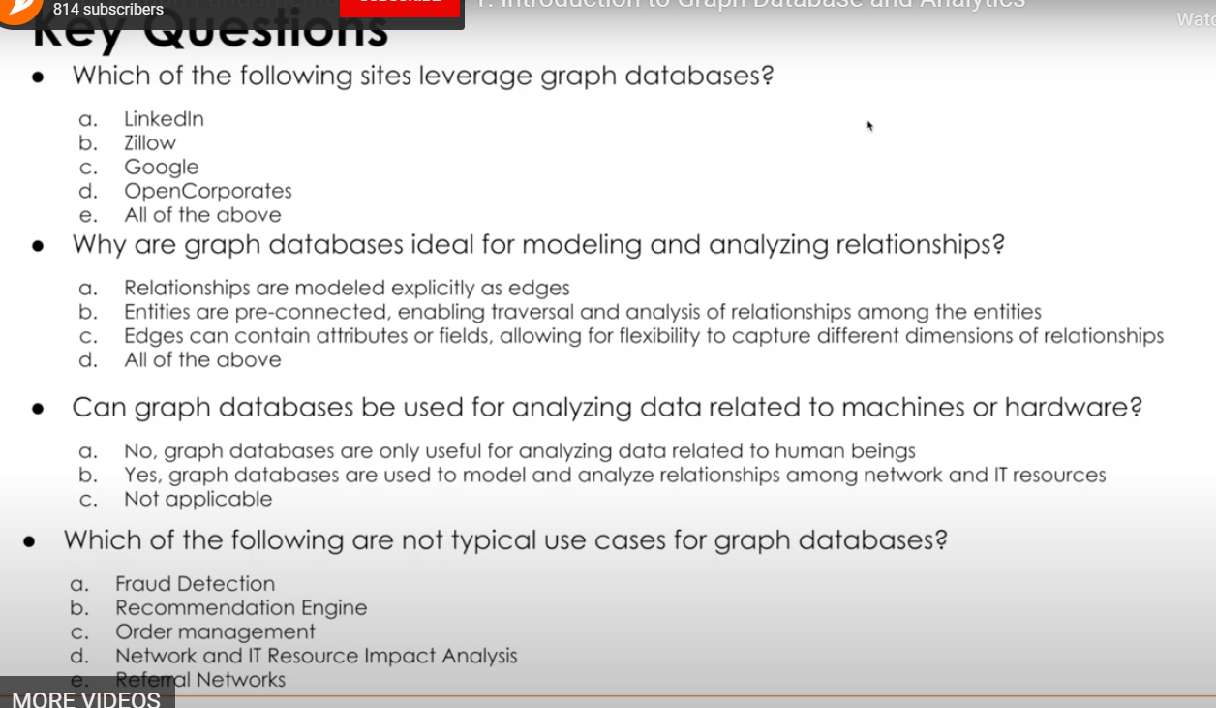

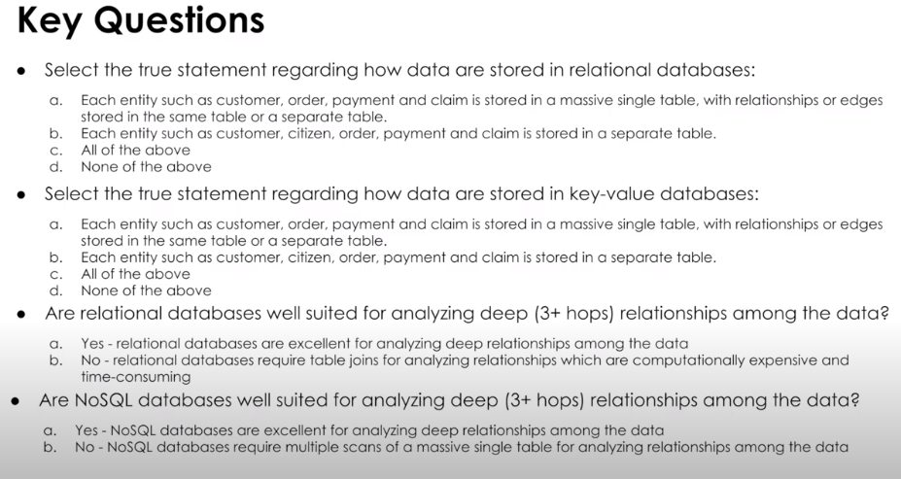

**Module 2 – Managing Relationships – Relational, NoSQL and Graph DB**

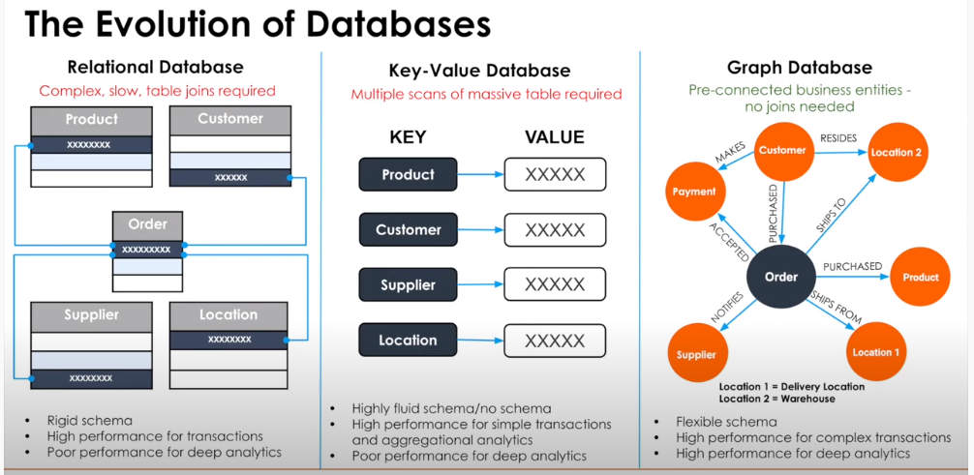

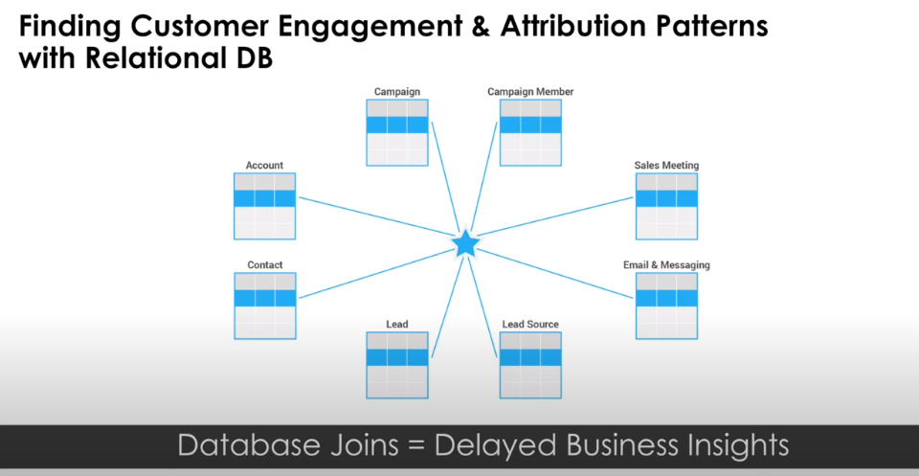

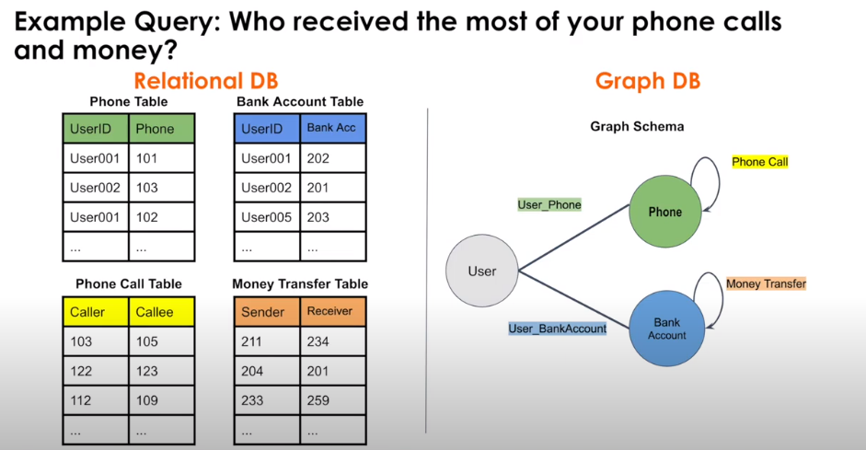

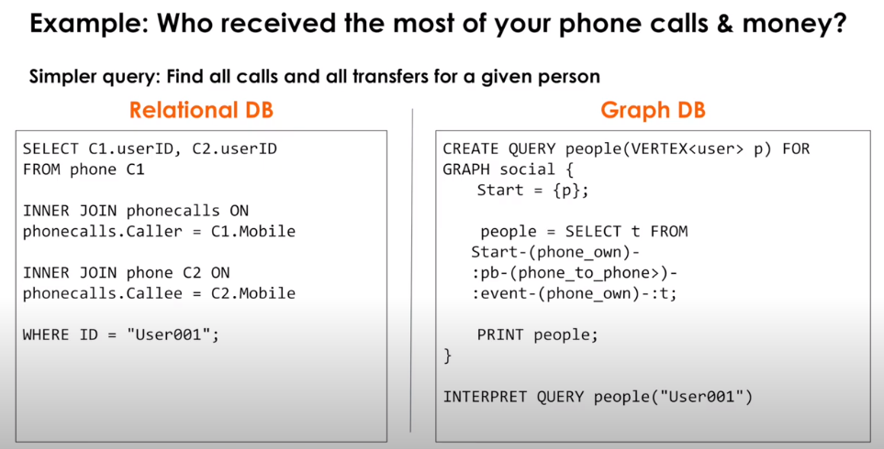

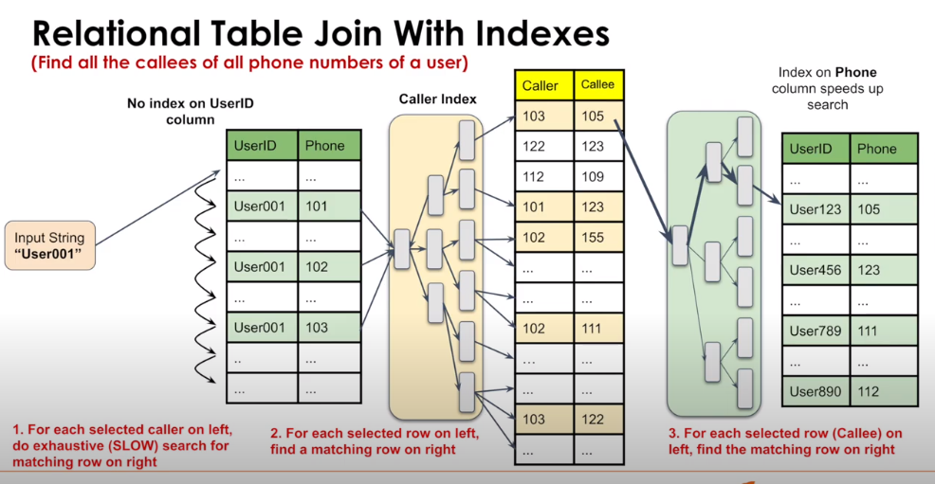

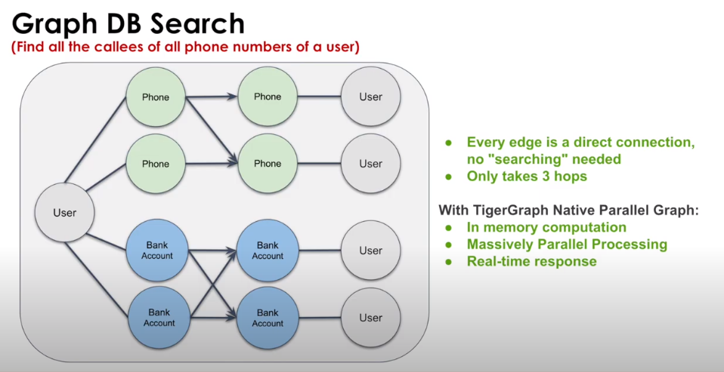

The graph structure stores relationships natively

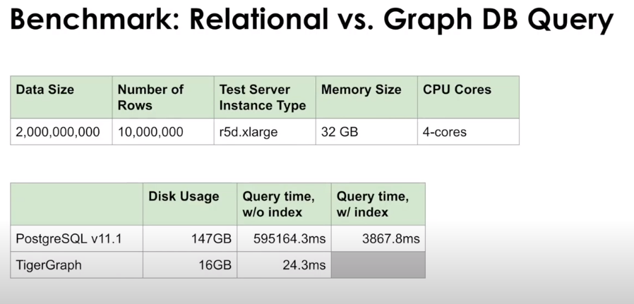

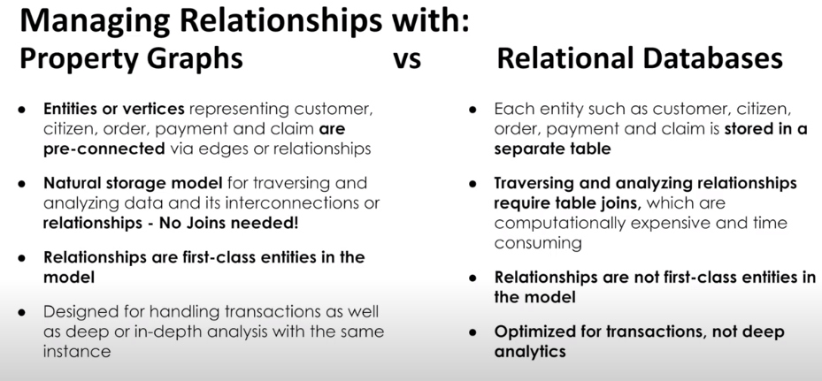

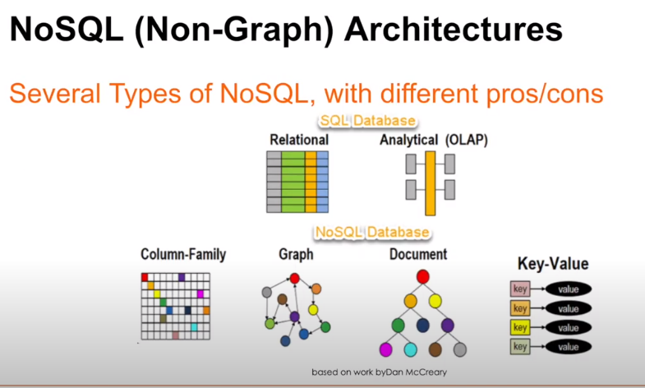

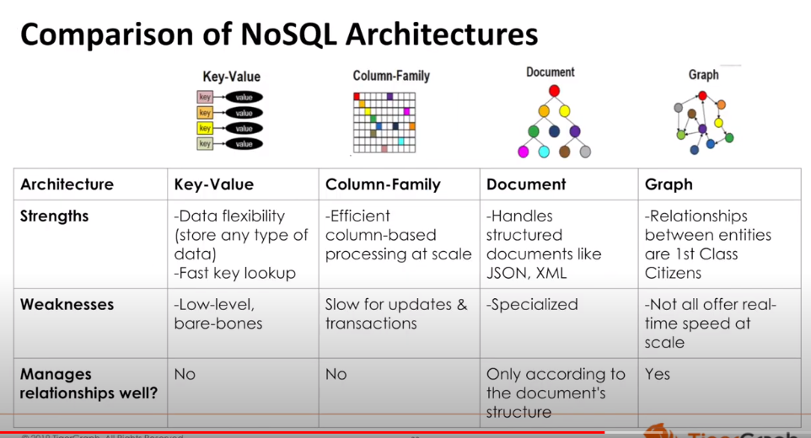

Key-value is little more than a data structure rather than a database  
Documents are very specialized for their use cases

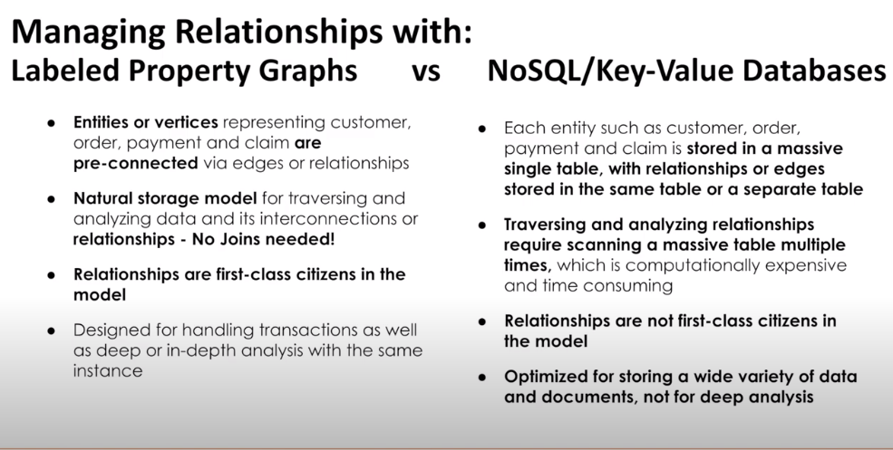

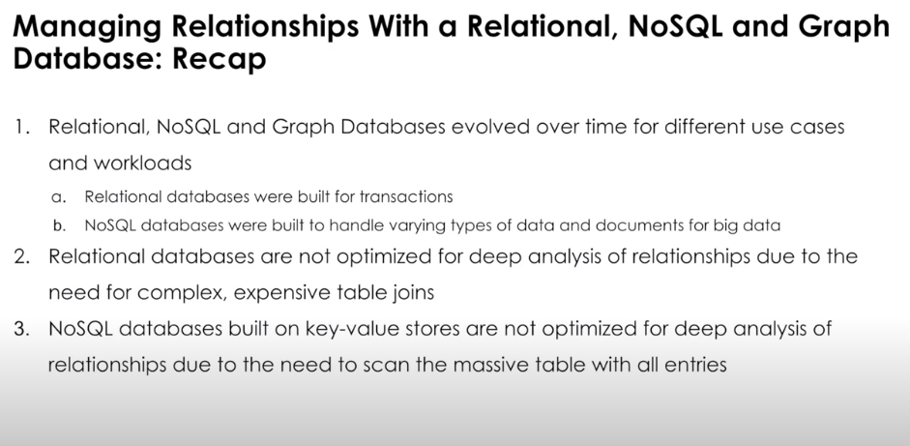

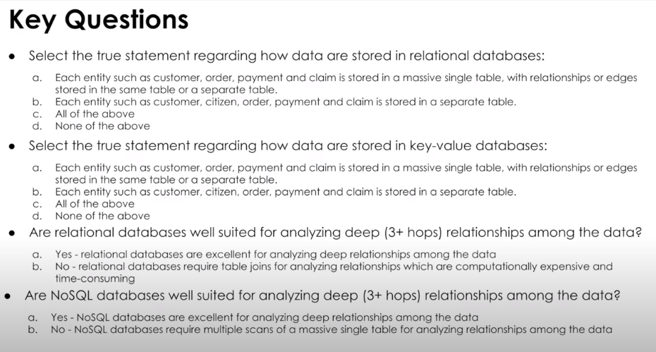

**Module 3 – Evolution of Graph Databases**

**Three generations of graph databases**

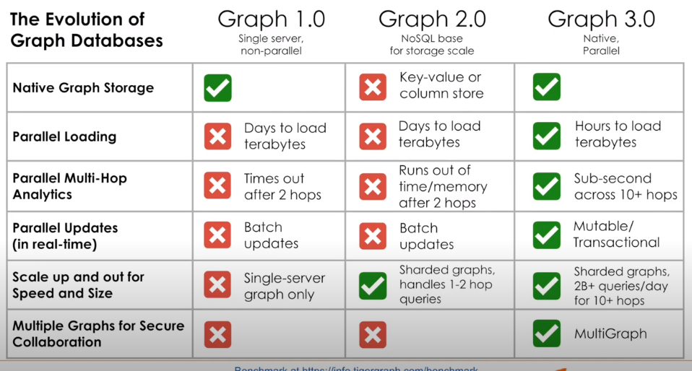

**Graph 1.0 - Neo4j   
Graph 2.0 – DataStax (solved the scalability problem, but don’t support native graph storage)  
Graph 3.0 – Tigergraph**

**Hybrid Transactional and Analytical Processing**

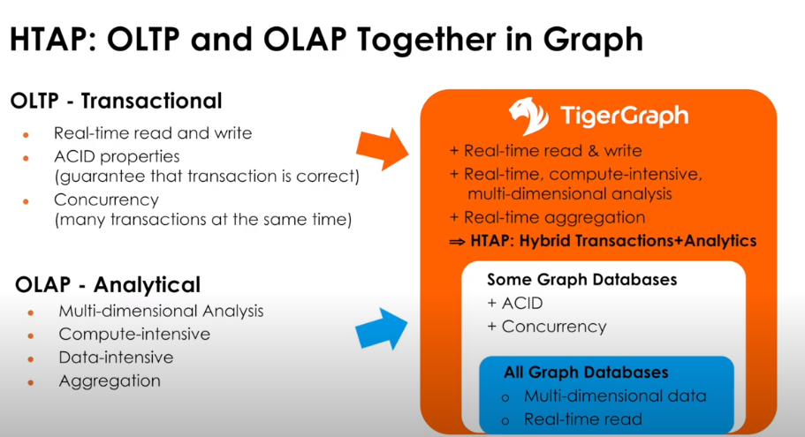

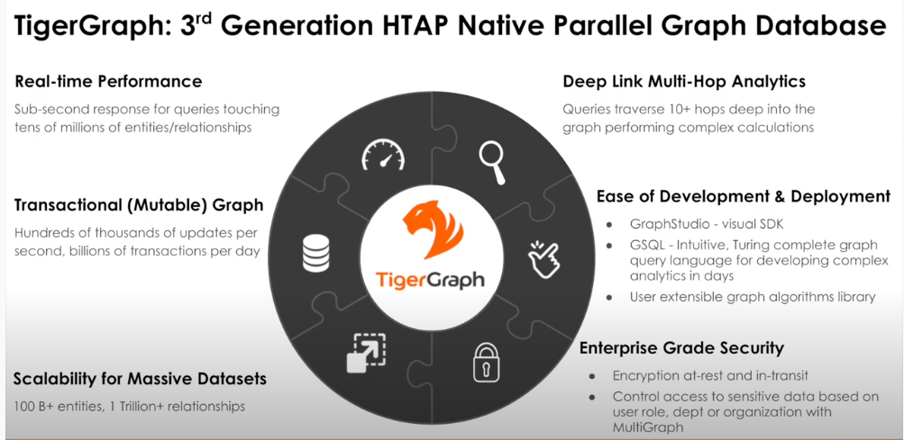

**Graph 2.0 such as key-value schemas are not mutable**

**Graph 2.0 doesn’t have capacity to support deep link analytics (use cases for looking for non-obvious relationships)**

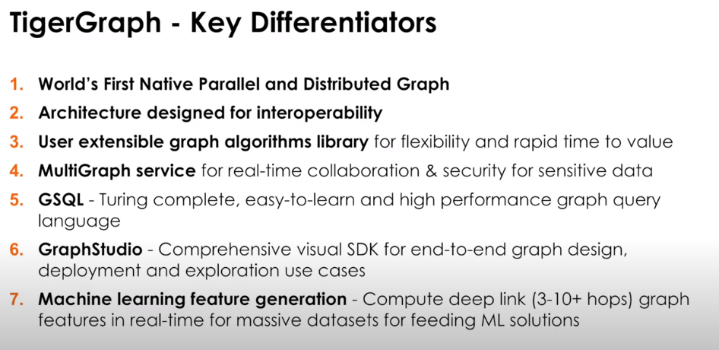

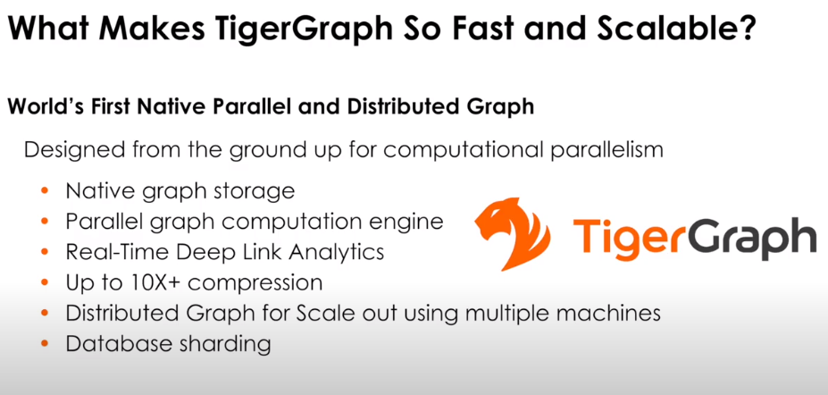

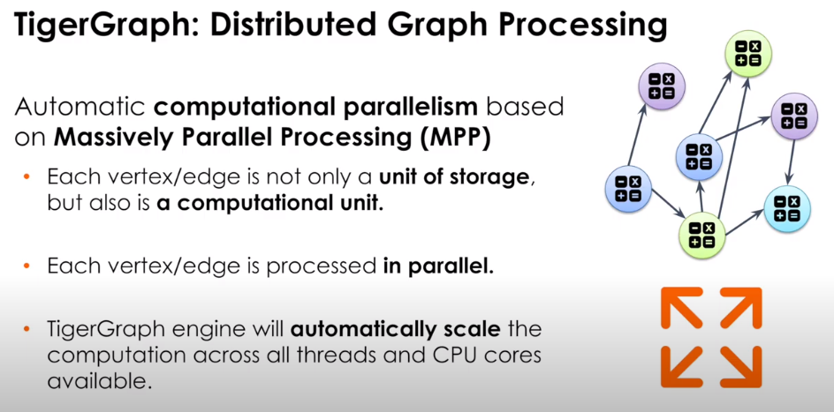

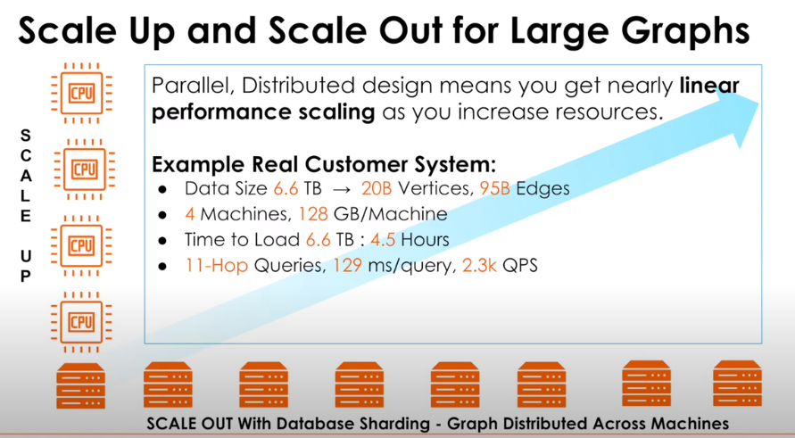

**Less expensive to shard data across multiple machines**

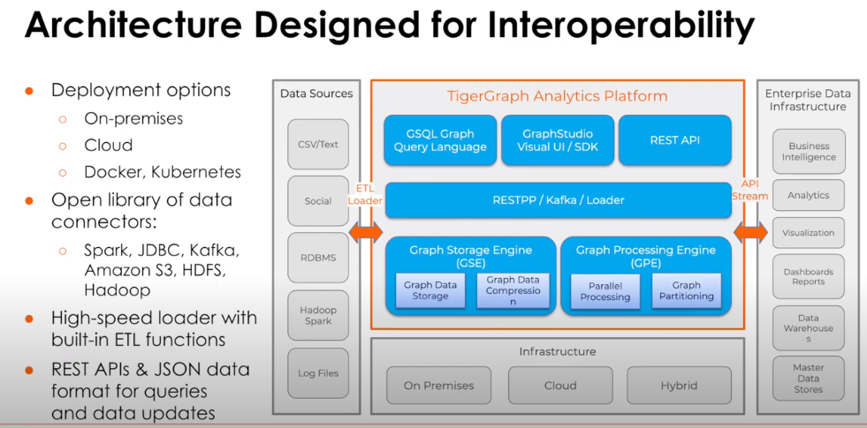

Supports Docker and K8s  
Available on cloud offerings  
  
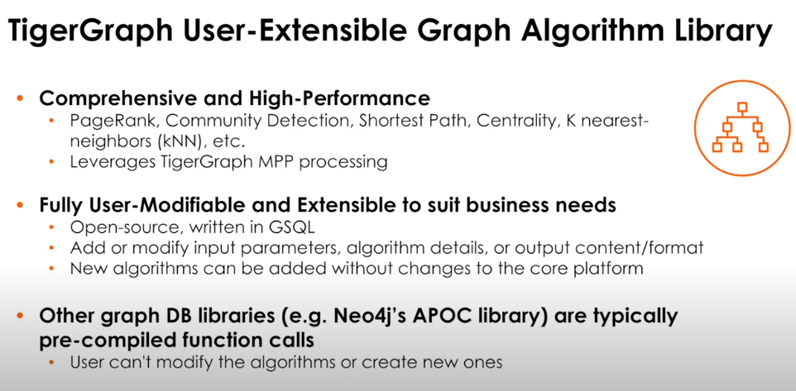

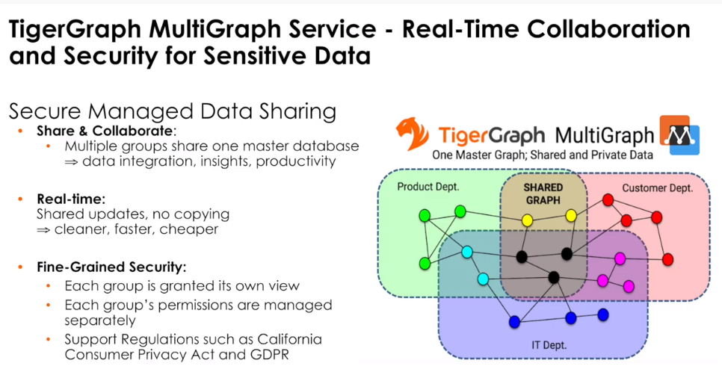

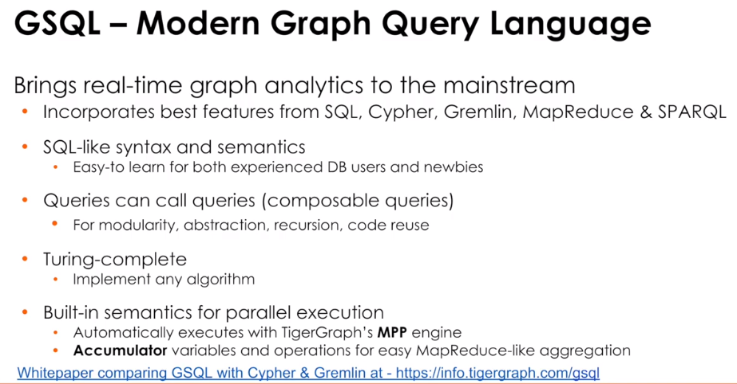

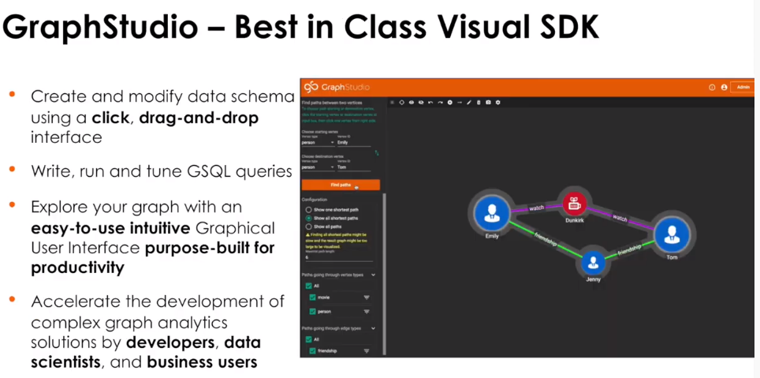

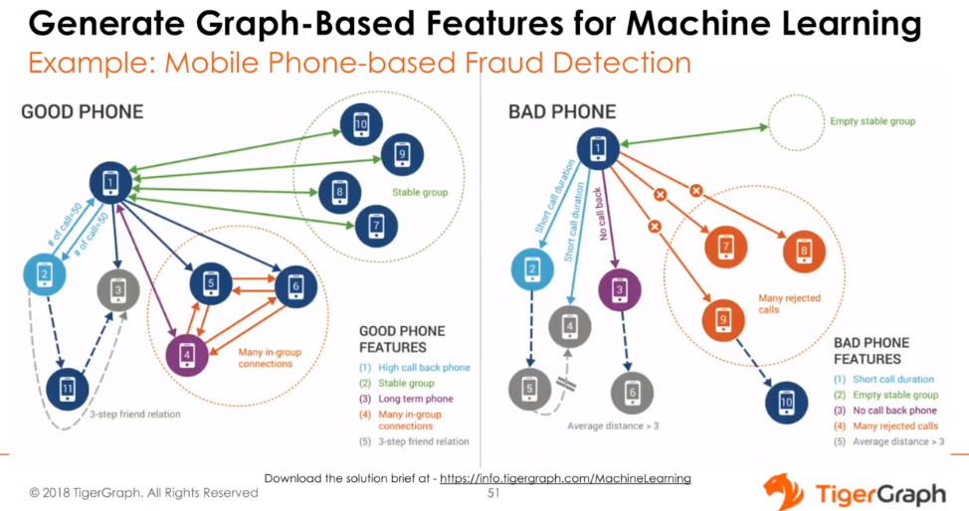

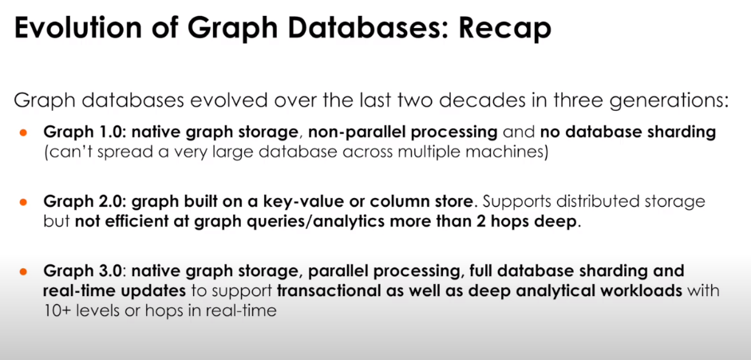

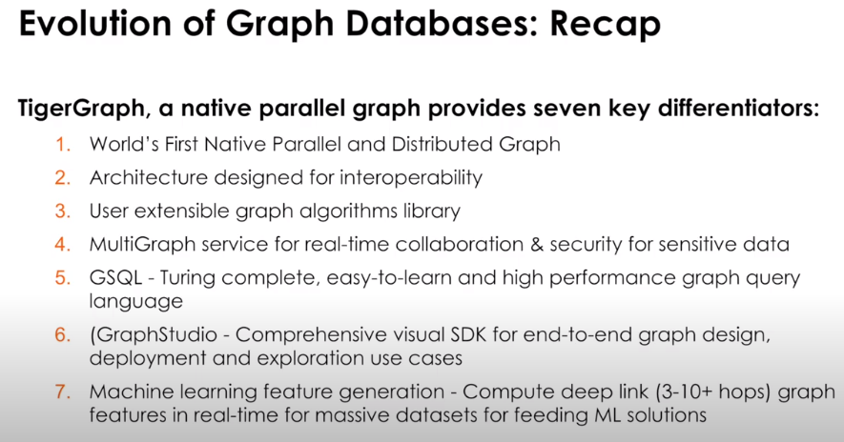

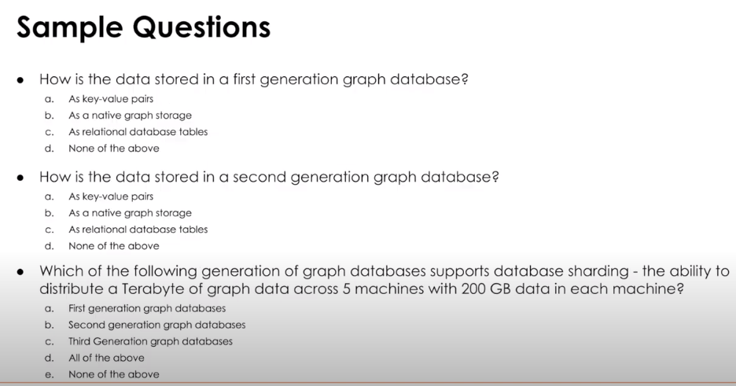

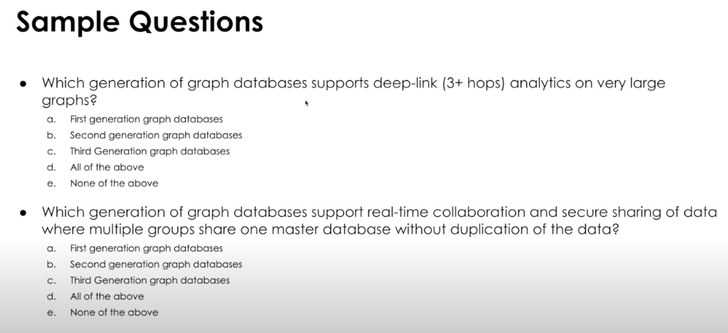

**Module 4 – Seven Key Data Science Capabilities of Native Parallel Graph Databases**

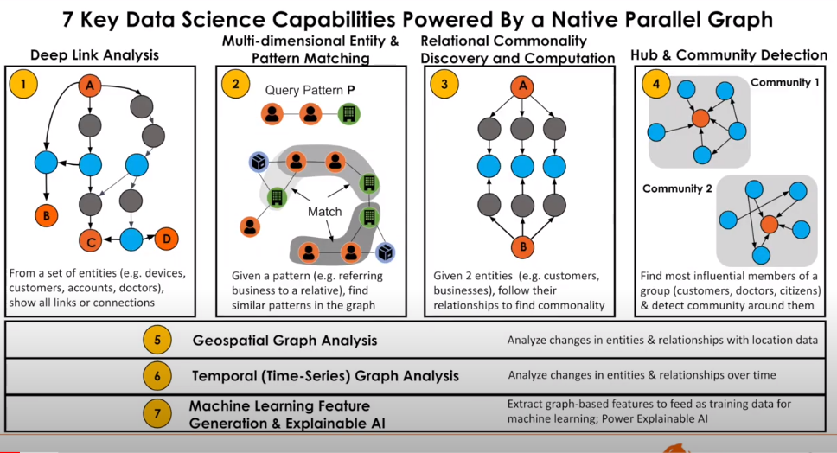

**Deep Link powers fraud detection, anti-money laundering and recommendation engines**

Pattern Matching powers use cases looking at similarities

**Relational Commonality powers use cases looking at similarities**

Hub and Community Detection powers use cases for “movers/influencers”

Geospatial powers location use cases (movement) (real-time campaigns)

Temporal Graph Analysis powers time series use cases (changes in behavior over time)

ML and Explainable AI

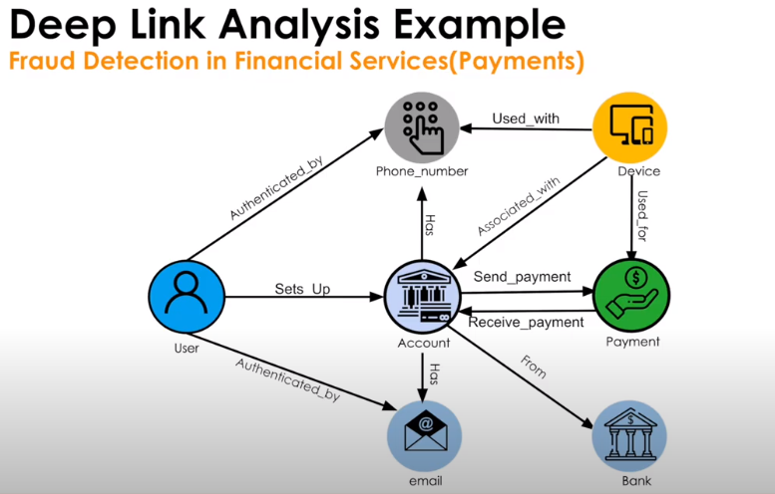

Example Use Case: Fraud Detection

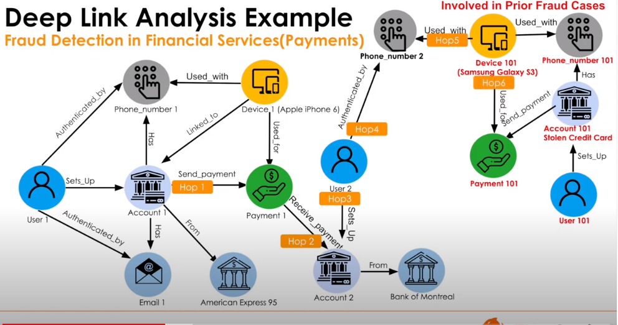

6-hop query

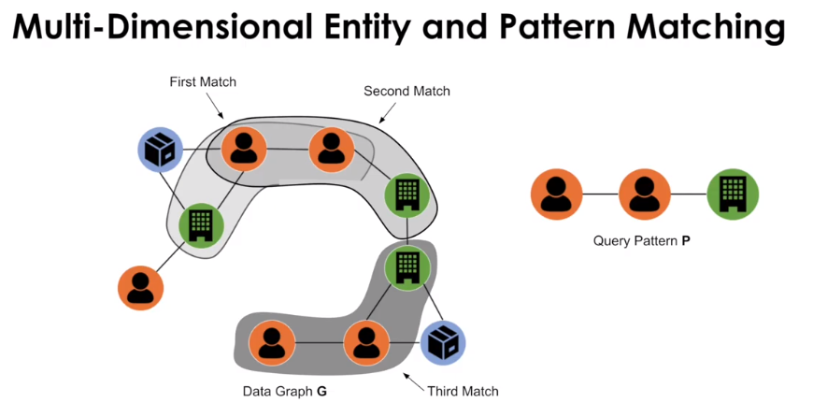

Find subgraphs within a graph

Pattern matchers can overlap

e.g. Product recommendations

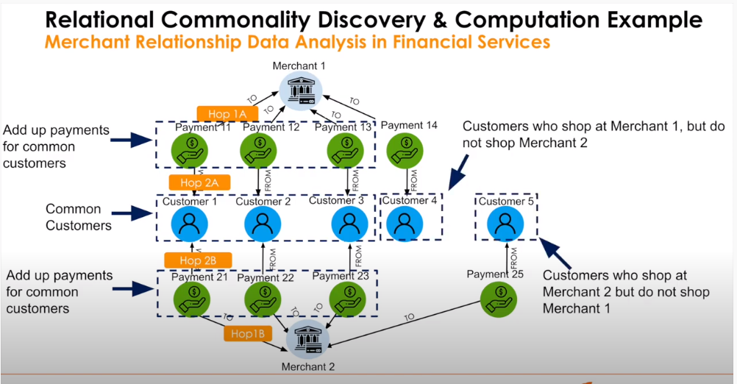

Time series can be layered on top to find trends in relationality over time

Also, cross-sell applications

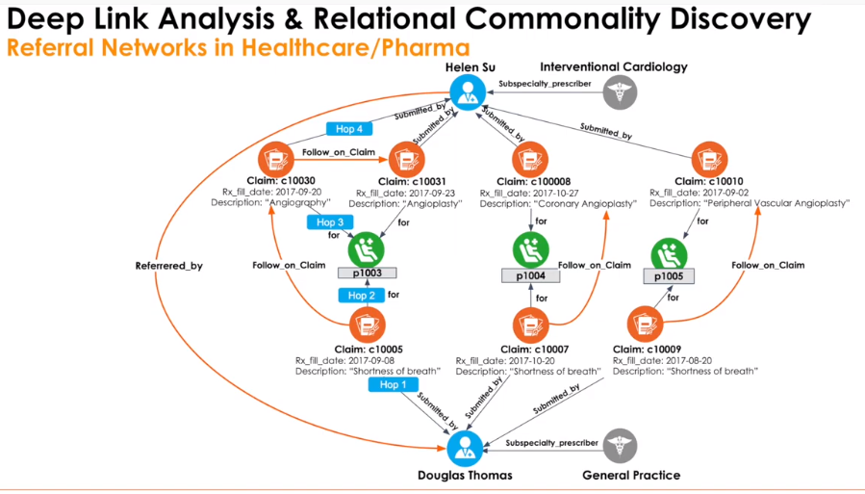

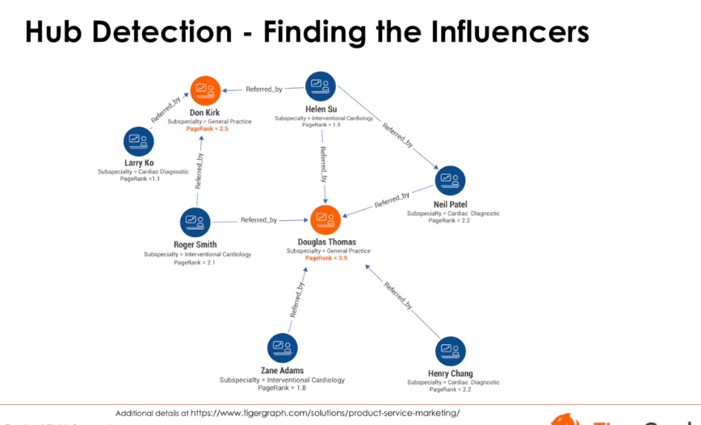

Identifying influential hubs

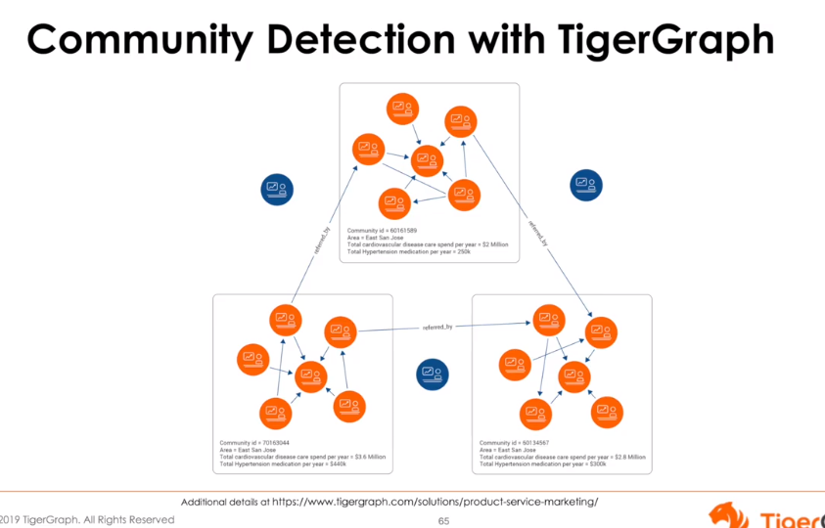

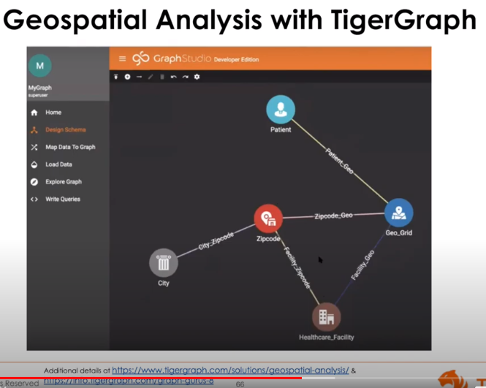

Grid points (lat/lon or zips)

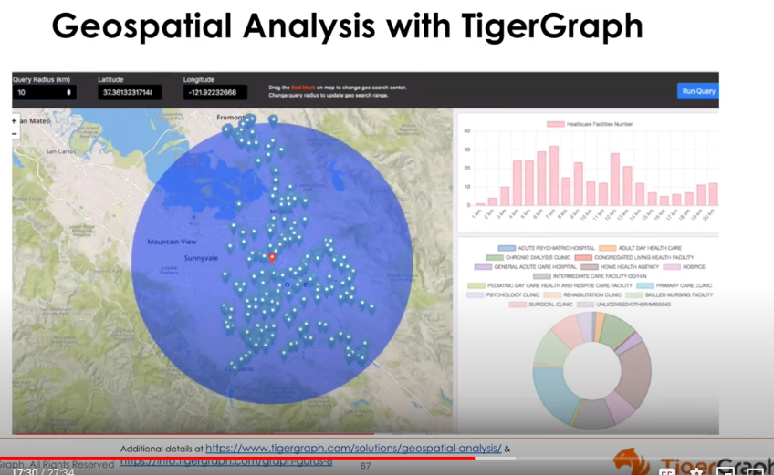

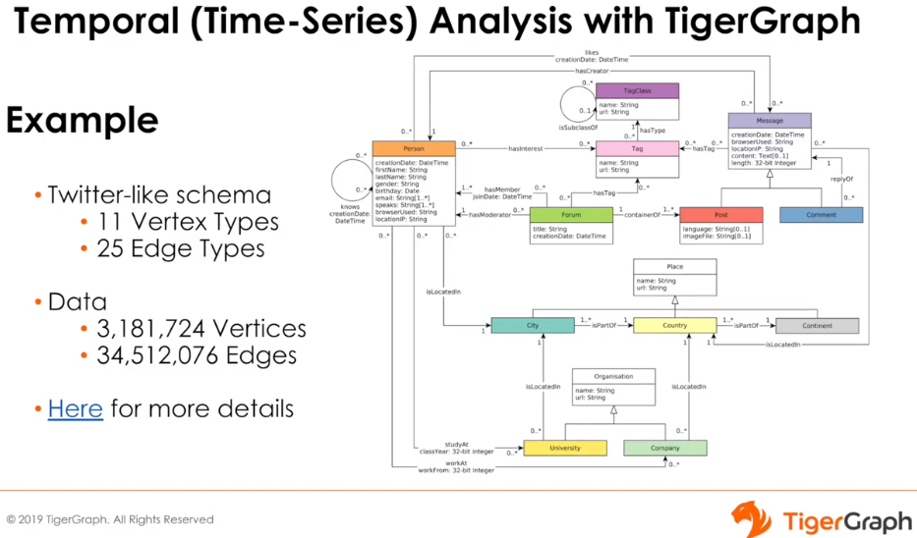

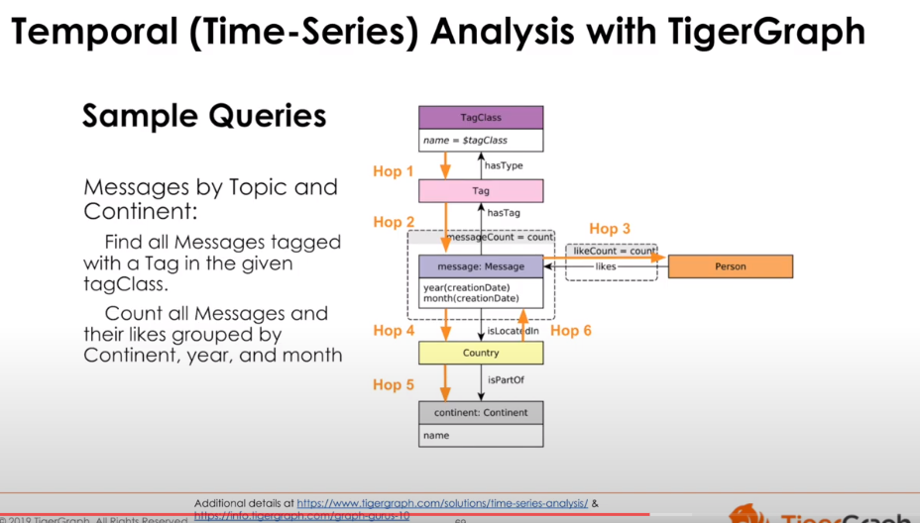

Linked Data Benchmark Council (LDBC)

**Accumulators**   
Runtime variables specifically designed for aggregation with distributed parallel processing

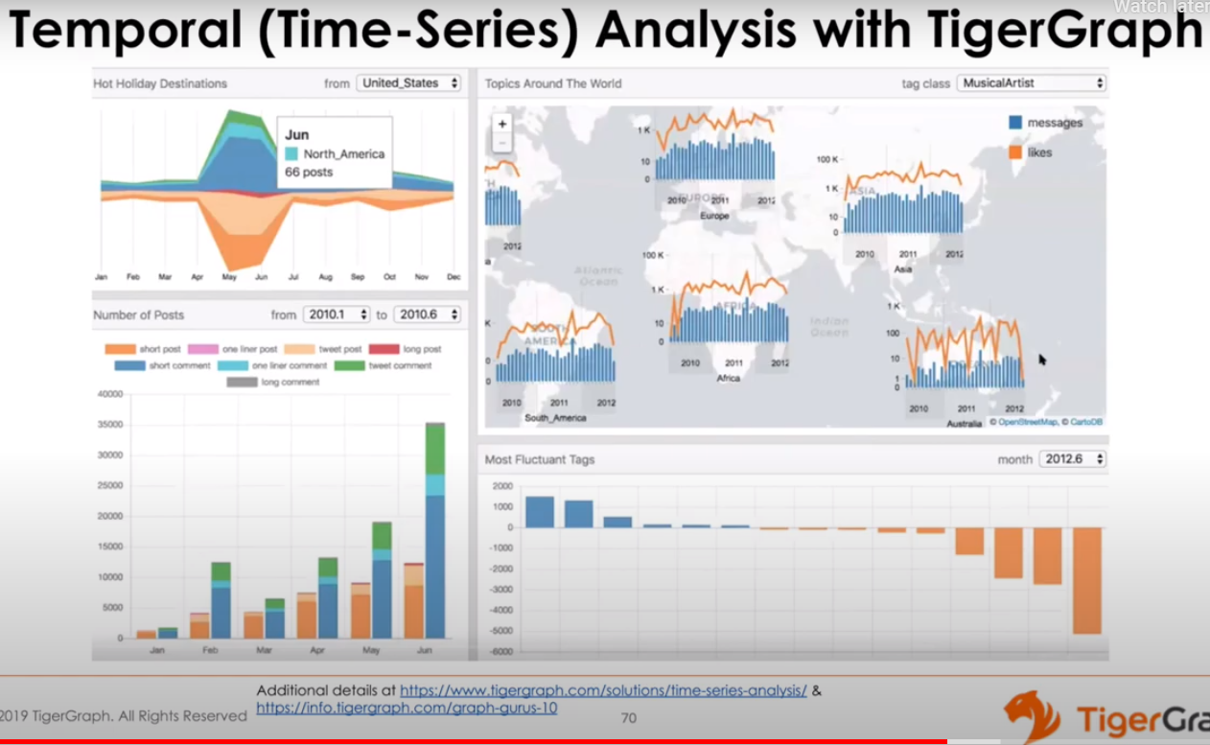

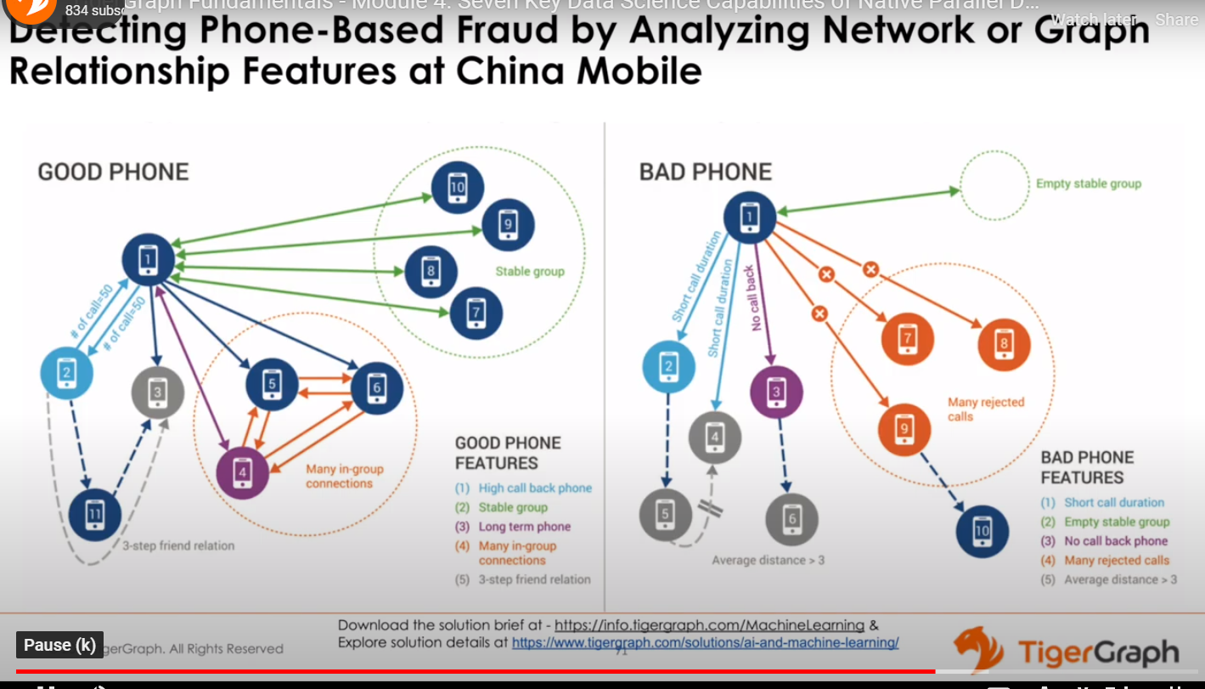

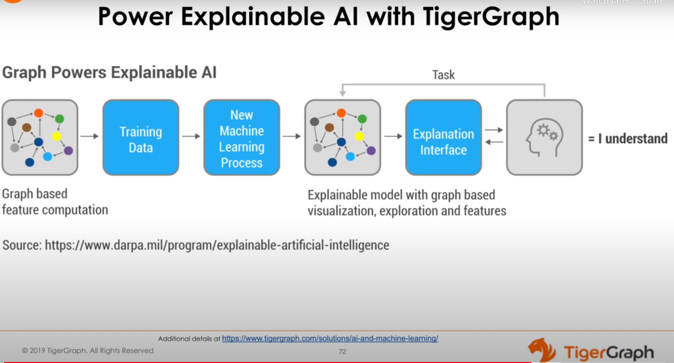

**Explainable AI**

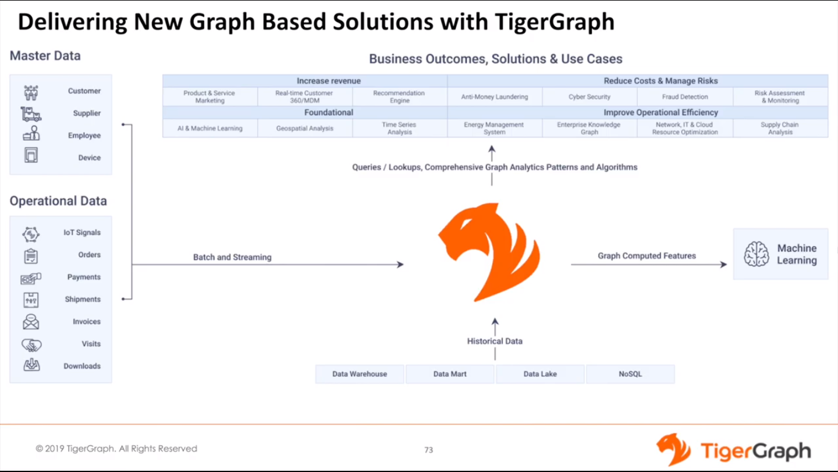

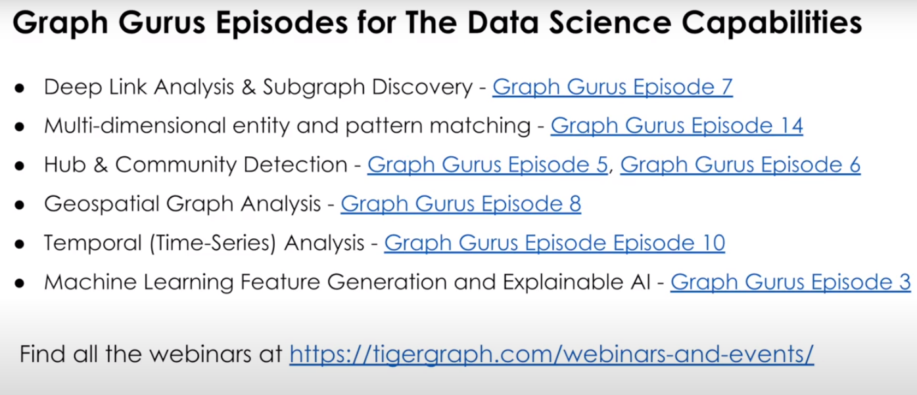

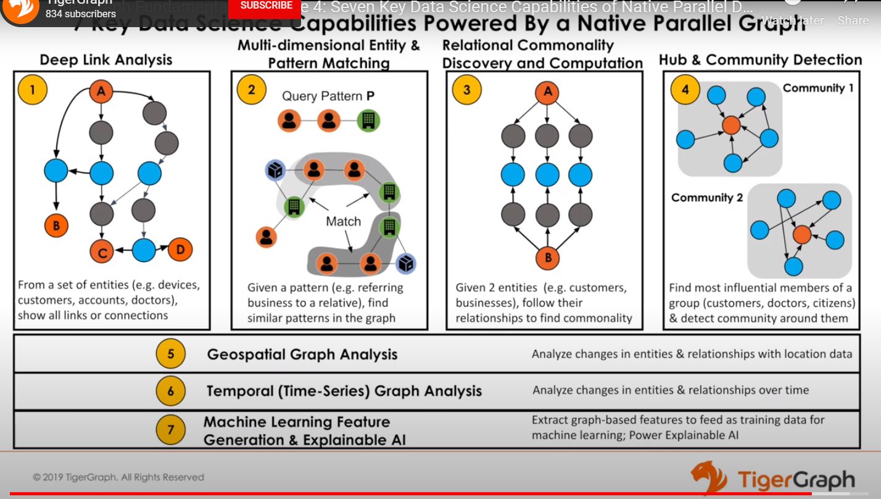

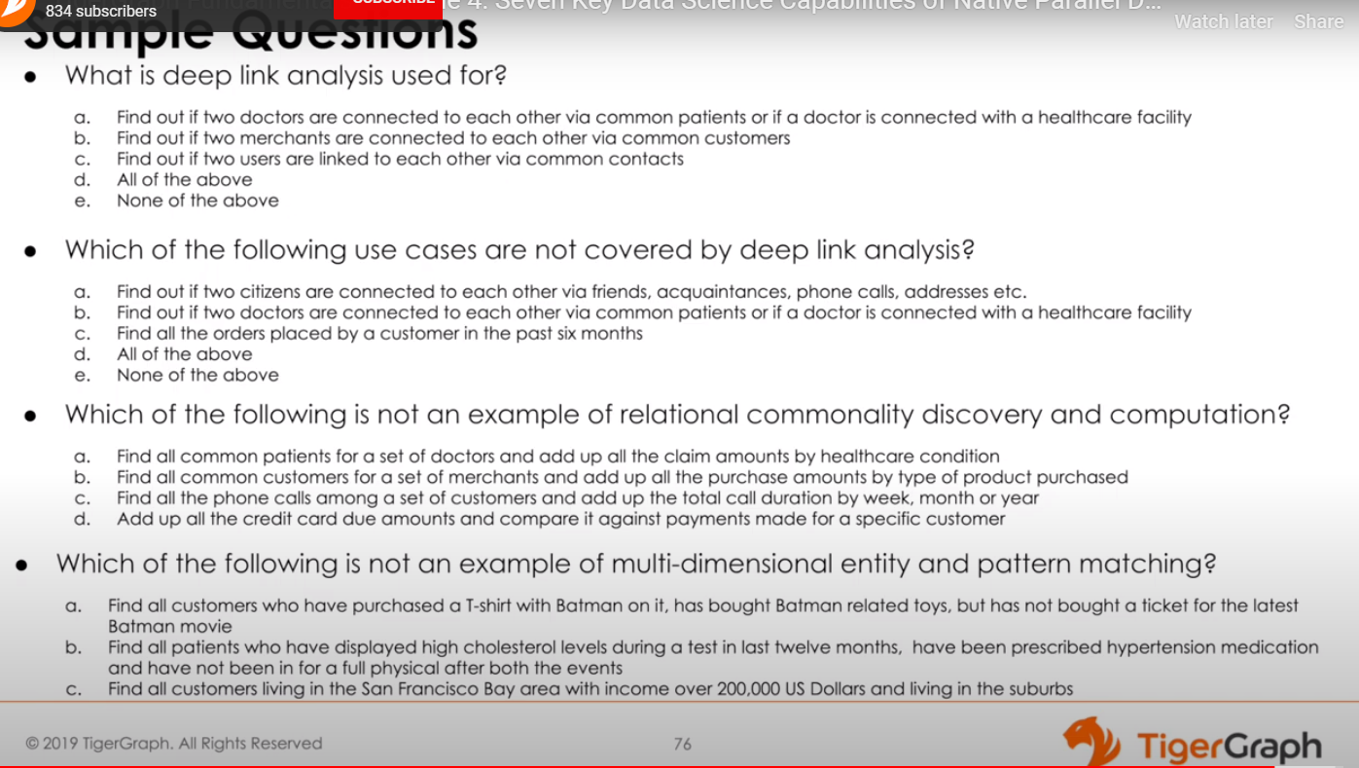

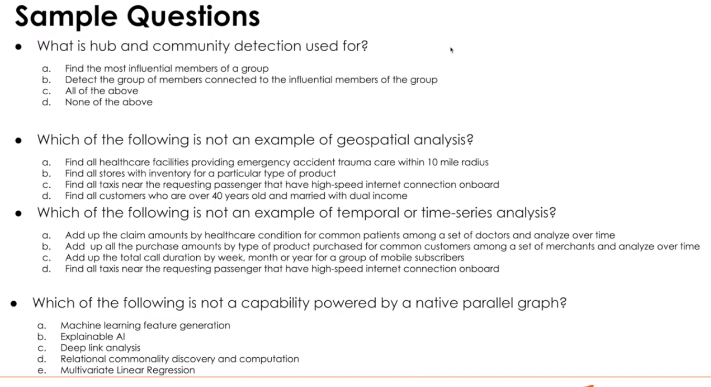

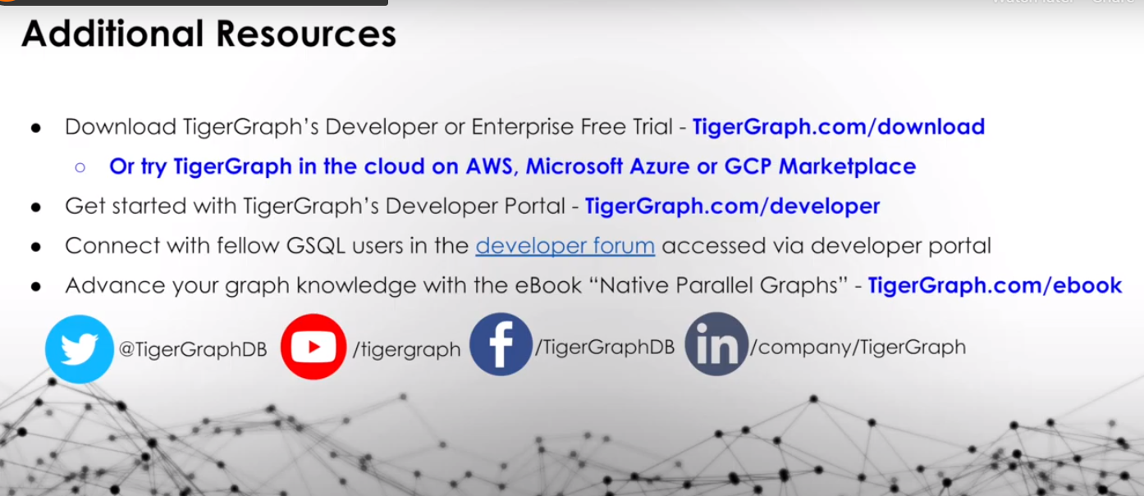

TIGERGRAPH CERTIFICATION: GSQL 101

**MODULE 1 – Graph Schema**

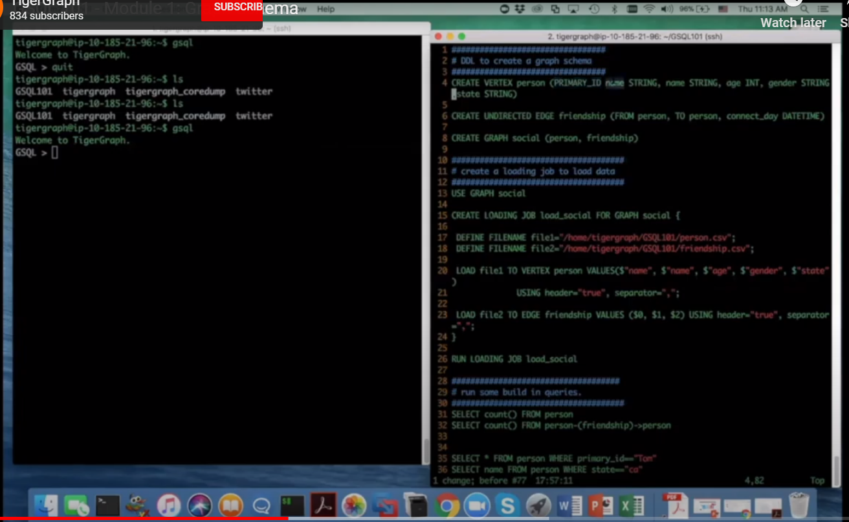

Vertices MUST have PRIMARY_ID

Edges need both FROM and TO

Can Be Symmetric (UNDIRECTED) or Asymmetric (DIRECTED)

CREATE GRAPH *graph_name* (*vertices, edges)*

**Module 2 – Data Loading**

Need to create a data mapping

1. Define a loading job
2. CREATE LOADING JOB *loading_job_name* FOR GRAPH *graph_name*
3. DEFINE FILENAME file_name=’*file_path*’
4. LOAD file_name TO VERTEX vertex_name VALUES($”primary id”, $field2) USING header=”true”, separator=”,”;
5. RUN LOADING JOB load_job name

**Module 3 – Graph Inspection Language**

USE GRAPH graph_name

SELECT count() FROM vertex_name

SELECT count() FROM person-(friendship)->person

SELECT * FROM person WHERE primary_id ==”Tom”

SELECT name FROM person WHERE state==”ca”

SELECT name, age FROM person WHERE age > 30

SELECT * FROM person-(friendship)->person WHERE from_id == “Tom”

**Module 4 – Basic GSQL**

Parameterized GSQL query syntax

CREATE QUERY query_name(VERTEX<person> p) FOR GRAPH graph_name{

Start = {p}; //

Result = SELECT tgt //one-hop edge block  
 FROM Start:src –(friendship:e)->person:tgt; //src,e,tgt are aliases

PRINT Result; //can print vertex set or list of expressions

}

INSTALL QUERY hello  
RUN QUERY hello “Tom”  
curl -X GET “http://localhost:9000/query/social/hello?p=Tom’

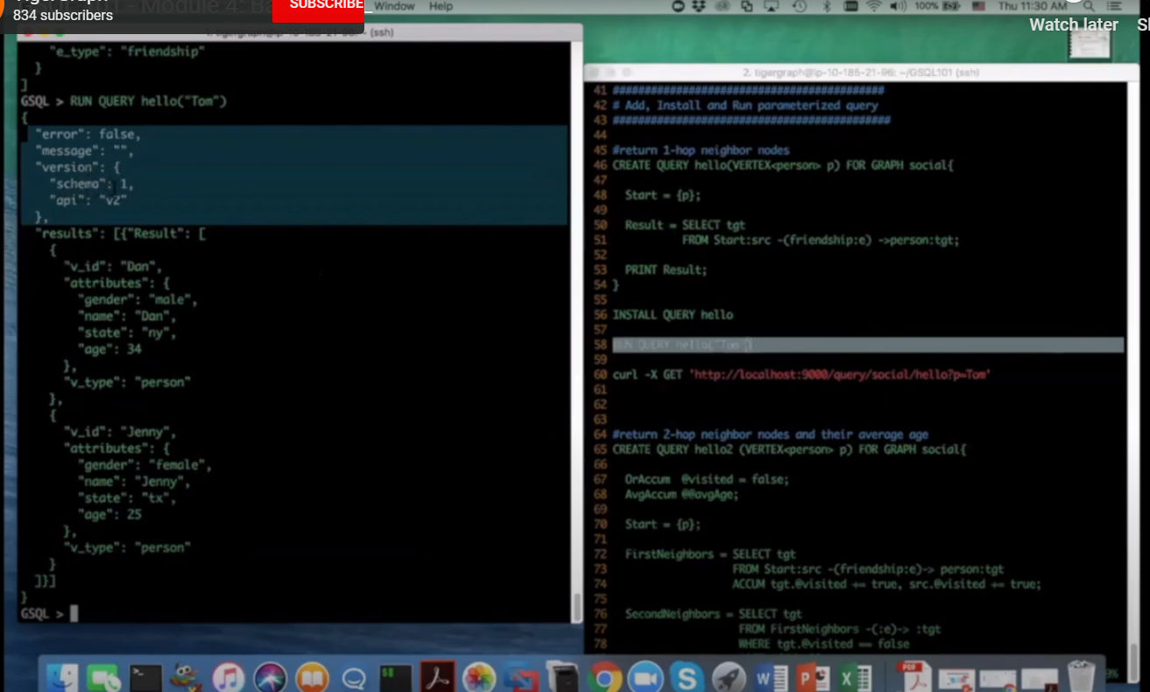

**Module 5 – Advanced GSQL (Accumulators)**

When you traverse a graph, you can leave marks on any vertex that you encounter

**Person**- age  
- gender

e.g. you can mark a node as “seen before”

+= is the accumulator operand

Accumulator can be local or global

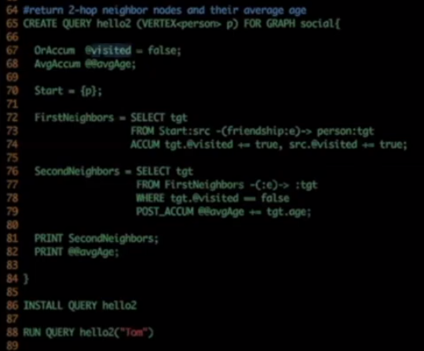

Local accumulator (precede with @)  
Global accumulator (precede with @@)

In the global memory space, the AvgAccum variable in the example above will be tracked.

ACCUM clause has implicit parallel operations

In SecondNeighbors clause, POST_ACCUM is used. POST_ACCUM is **sequential.**Who will reach the POST_ACCUM?   
1. runtime attributes are updated by the ACCUM clause  
2. Selected by the select clause  
3. can directly reference specific vertices in the POST_ACCUM clause  
  
All vertices will be sequentially executed in the POST ACCUM clause

**Module 6 – Deep Link Query**

**Deep link query in 1 billion edge graph is benchmark**

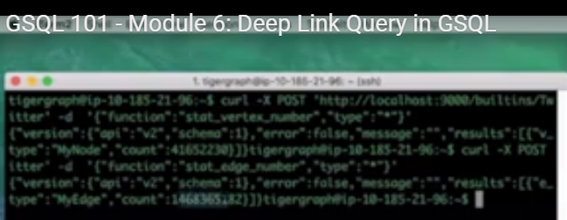

**Use graph Twitter**

**K-hop query**

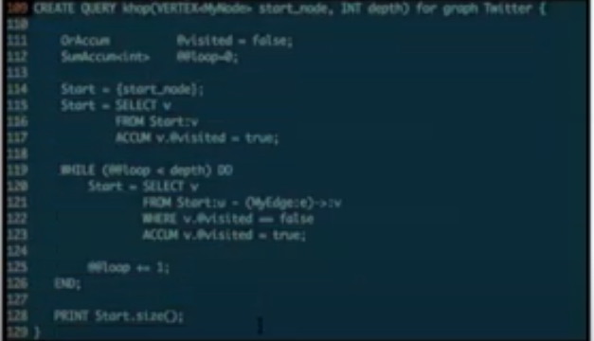

depth is parameterized

GSQL allows for flow control; can loop the depths recursively

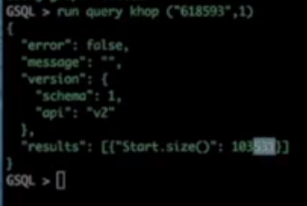

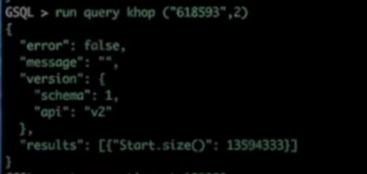

Set query_timeout=1000000

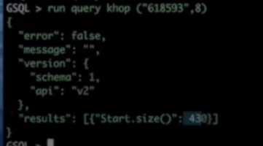

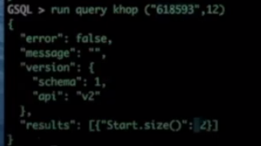

**RESOURCES**

<https://tgcloud.io/app/solutions>  
[joe_dilauro@optum.com](mailto:joe_dilauro@optum.com)  
MartinD45

1. **CREATE SOLUTION**

**SELECT TIGERGRAPH VERSION**3.0.5

**Select a Start Kit** Blank v3

**Instance Settings**

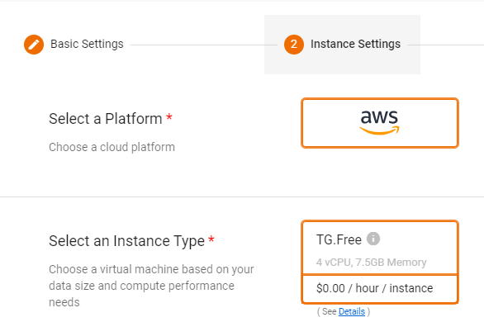

**Select Region**N. Virginia

**Disk Size**50GB

**Partition Factor**1

**Replication Factor**1

**Name Your Solution**Herb_Graph

**Tag Your Solution**herbs

**Set the Initial Password**MartinD45

**Subdomain**herbs.i.tgcloud.io

**Description**Herbal Remedies

*Wait a few minutes*

1. **Open GraphStudio**

**tigergraph  
MartinD45**

1. **CREATE A GRAPH**

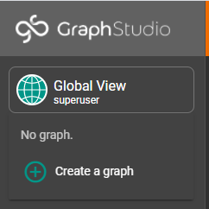

**Herbs**

1. **CREATE SCHEMA**
2. **Add Vertices from** [**https://github.com/FineRhino/tigergraph/tree/main/data**](https://github.com/FineRhino/tigergraph/tree/main/data)
   1. **Herb**
      1. **id**   
         (using common name)  
         Example: Linden
      2. **formalName**(Latin name)   
         Example: Tilia spp
      3. **commonName**   
         (Common Name – in English)   
         Example: Linden
   2. **Organ**
      1. **id**(using common name)   
         Example: Skin
      2. **name**   
         (using common name)   
         Example: Skin
   3. **OrganSystem**
      1. **id**(using common English name)   
         Example: Digestive
      2. **name**(using common English name)   
         Example: Digestive
      3. **description**   
         (description of system)  
         Example: The digestive system ingests food and breaks it down into usable nutrients before excreting solid waste products
   4. **Person**
      1. **id**Example: Joe
      2. **firstName**

Example: Joe

* + 1. **lastName**

Example: DiLauro

* 1. **Year**
     1. **id**Example: 1974
     2. **year**

Example: 1974

* 1. **HealingProperty**
     1. **id**  
        Example: Nervine
     2. **name**Example: Nervine
     3. **description**

Example: substance which has calming effect on nervous system

1. **Add Edges From** [**https://github.com/FineRhino/tigergraph/tree/main/data**](https://github.com/FineRhino/tigergraph/tree/main/data)
   1. **Edge_Herb_has_healing_property_Healing_Property**
      1. **Herb.id**

Example: Marshmallow

* + 1. **HealingProperty.id**Example: Demulcent
  1. **Edge_Herb_is_friend_of_Herb**
     1. **Herb.id**Example: Linden
     2. **Herb.id**Example: Marshamallow
  2. **Edge_Organ_is_part_of_OrganSystem**
     1. **Organ.id**

Example: Skin

* + 1. **OrganSystem.id**Example: Integumentary
  1. **Edge_Person_is_friends_with_Person**
     1. **Person.id**Example: Joe
     2. **Person.id**

Example: Tim

* 1. **Edge_Person_uses_herb_Herb**
     1. **Person.id**

Example: Joe

* + 1. **Herb.id**

Example: Garlic

* 1. **Edge_Person_was_born_in_Year**
     1. **Person.id**

Example: Joe

* + 1. **Year.id**

Example: 1974

1. **Publish Schema**
2. **Map Data to Graph**
3. **Load Data**
4. **Explore Graph**
5. **Write Queries**
   1. **SELECT_Person_By_ID**

**Use Case:**

Find a person in the graph by ID

**Query Syntax:**

CREATE QUERY SELECT_Person_By_ID(VERTEX<Person> p) FOR GRAPH Herbs {

Start={p};

Result = SELECT src

FROM Start:src;

PRINT Result;

}

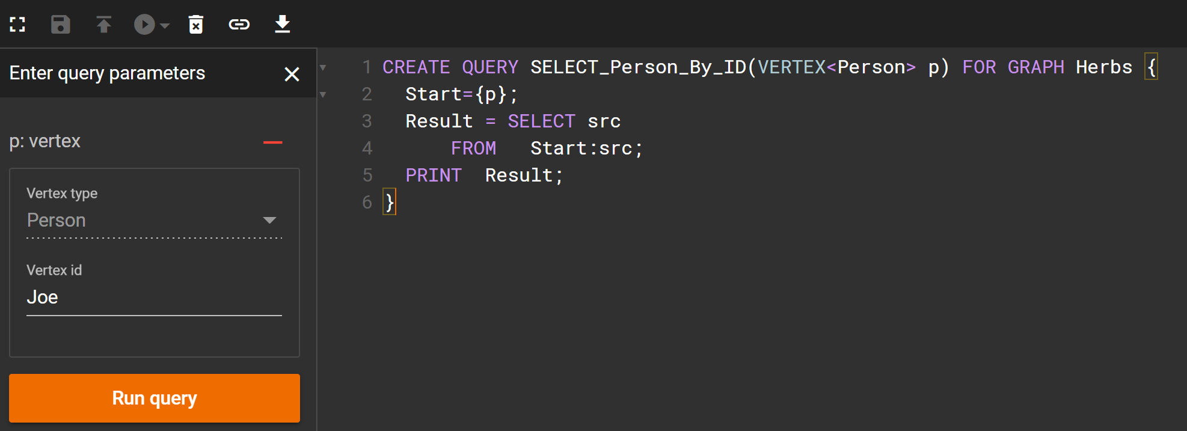

Query Endpoint:  
[https://herbs.i.tgcloud.io:9000/query/Herbs/SELECT_Person_By_ID?p=<VERTEX_ID](https://herbs.i.tgcloud.io:9000/query/Herbs/SELECT_Person_By_ID?p=%3cVERTEX_ID)>

When first trying to run the query, you will get:   
{"version":{"edition":"enterprise","api":"v2","schema":2},"error":true,"message":"Access Denied because the input token = '' is invalid for graph 'Herbs'","code":"REST-10016"}

Need to create a token.

* 1. **SELECT_Person_Uses_Herb**

**Use Case:**

Find all of the herbs that a certain Person uses.

**Query Syntax:**

CREATE QUERY SELECT_Person_Uses_Herb(VERTEX<Person> p) FOR GRAPH Herbs {

Start = {p};

Result = SELECT h

FROM Start:s-(Edge_Person_uses_herb_Herb:e)->Herb:h;

PRINT Result;

}

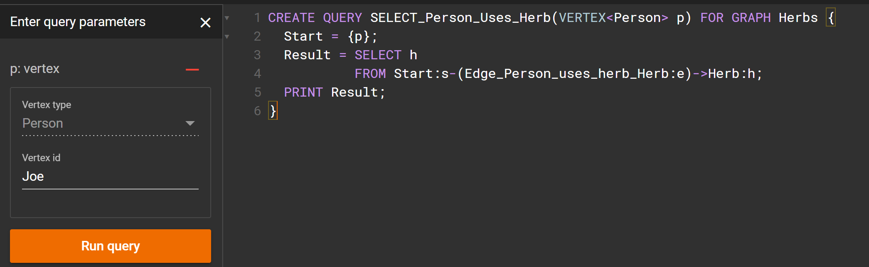

This is a simple 1-hop.

<https://docs.tigergraph.com/start/gsql-101/parameterized-gsql-query#a-simple-1-hop-query>

We select all edges beginning from the given source set (Start), which have the given edge type (Edge_Person_uses_herb_Herb) and which end at the given vertex type (Herb). A feature we haven't seen before is the use of vertex and edge set aliases defined by ":alias": "s" is the alias for the source vertex set, "e" is the edge set alias, and "h" is the target vertex set alias.

* 1. **SIMILARITY_Search_People_Using_Common_Herbs_By Herb**  
     **Use Case:**  
     Search graph to find all users who use an herb in common. For example, if both Joe and Amy use Linden, then the query would return Joe and Amy when Linden was entered as a parameter.

**Query Syntax:**

CREATE QUERY SIMILARITY_Search_People_Using_Common_Herbs(VERTEX<Herb> h) FOR GRAPH Herbs {

Start = {h};

Result = SELECT p

FROM Start:s-(Edge_Person_uses_herb_Herb:e)->Person:p;

PRINT Result;

}

* 1. **SIMILARITY_Search_People_Using_Common_Herbs_By_Highest_Count**

**Use Case:**  
Search graph to find the herb or herbs that have the most users in common. This requires that all Edge_Person_uses_herb_Herb edges be counted, accumulated, and that the result set is sorted by highest edge count. The response should indicate the herb and how many people use the herb. This would be similar to a consumption graph uses by retailers to find products which have highest consumption across multiple users.

**Type of Query:**Relational Commonality or Hub and Community Detection

**Query Syntax:**

CREATE QUERY SIMILARITY_Search_People_Using_Common_Herbs(VERTEX<Herb> h) FOR GRAPH Herbs {

Start = {h};

Result = SELECT p

FROM Start:s-(Edge_Person_uses_herb_Herb:e)->Person:p;

PRINT Result;

}

**Relational Model**

**Table - Persons**

|  |
| --- |
| **Name** |
| Joe |
| Amy |
| Tim |

**Table - Herbs**

|  |
| --- |
| **Name** |
| Linden |
| Thyme |
| Garlic |
| Marshmallow |

**Table – Person_Herbs**

|  |  |
| --- | --- |
| **Person Name** | **Herb Name** |
| Joe | Linden |
| Joe | Thyme |
| Joe | Marshmallow |
| Amy | Linden |
| Amy | Garlic |
| Tim | Garlic |
| Tim | Linden |

SELECT ph.Person_Name, ph.Herb_Name, C.cnt

FROM Person_Herbs ph

INNER JOIN ( SELECT Herb_Name, count(Herb_Name) as cnt  
 FROM Person_Herb

GROUP_BY Herb_Name) C

ON ph.Herb_Name = C.Herb_Name

1. **Create a New Secret and Generate a Token for Authentication**

<https://docs.tigergraph.com/admin/admin-guide/user-access-management/user-privileges-and-authentication>

Specifically, see <https://docs.tigergraph.com/admin/admin-guide/user-access-management/user-privileges-and-authentication#rest-authentication>

Each REST++ request should contain an authorization token in the HTTP header. The REST++ server reads the header. If the token is not valid, REST++ will refuse to run the query and instead will return an authentication error.

* 1. **Generate a New Secret**
     1. Go to Admin Page
     2. Create a new alias

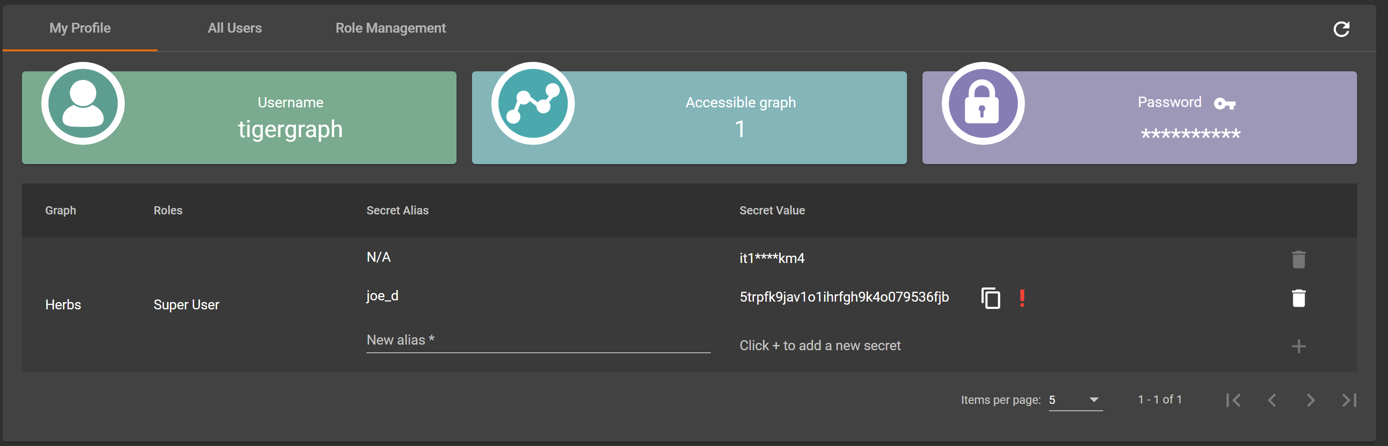

1. **Set up PostMan**
   1. **Get Token Request**
      1. Create new request in PostMan
      2. [https://herbs.i.tgcloud.io:9000/requesttoken?secret=5trpfk9jav1o1ihrfgh9k4o079536fjb](i.%09https:/herbs.i.tgcloud.io:9000/requesttoken?secret=5trpfk9jav1o1ihrfgh9k4o079536fjb)
      3. Add Basic Authentication

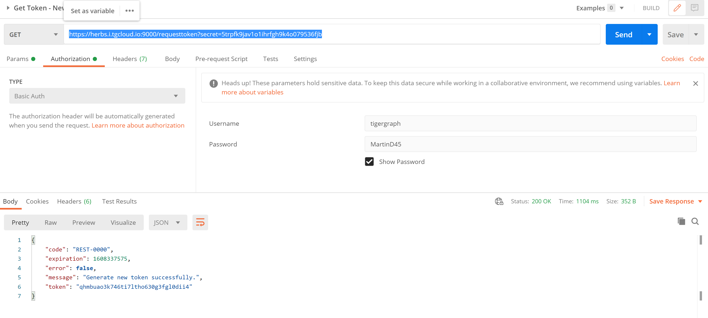

* 1. **Create a New Request**
     1. Create a new request in PostMan
     2. Copy the endpoint from GraphStudio
     3. <https://herbs.i.tgcloud.io:9000/query/Herbs/SELECT_Person_By_ID?p=Dwight>
     4. Select OAuth 2.0 Authentication
     5. Place the Access Token from your Get Token request into the Access Token box

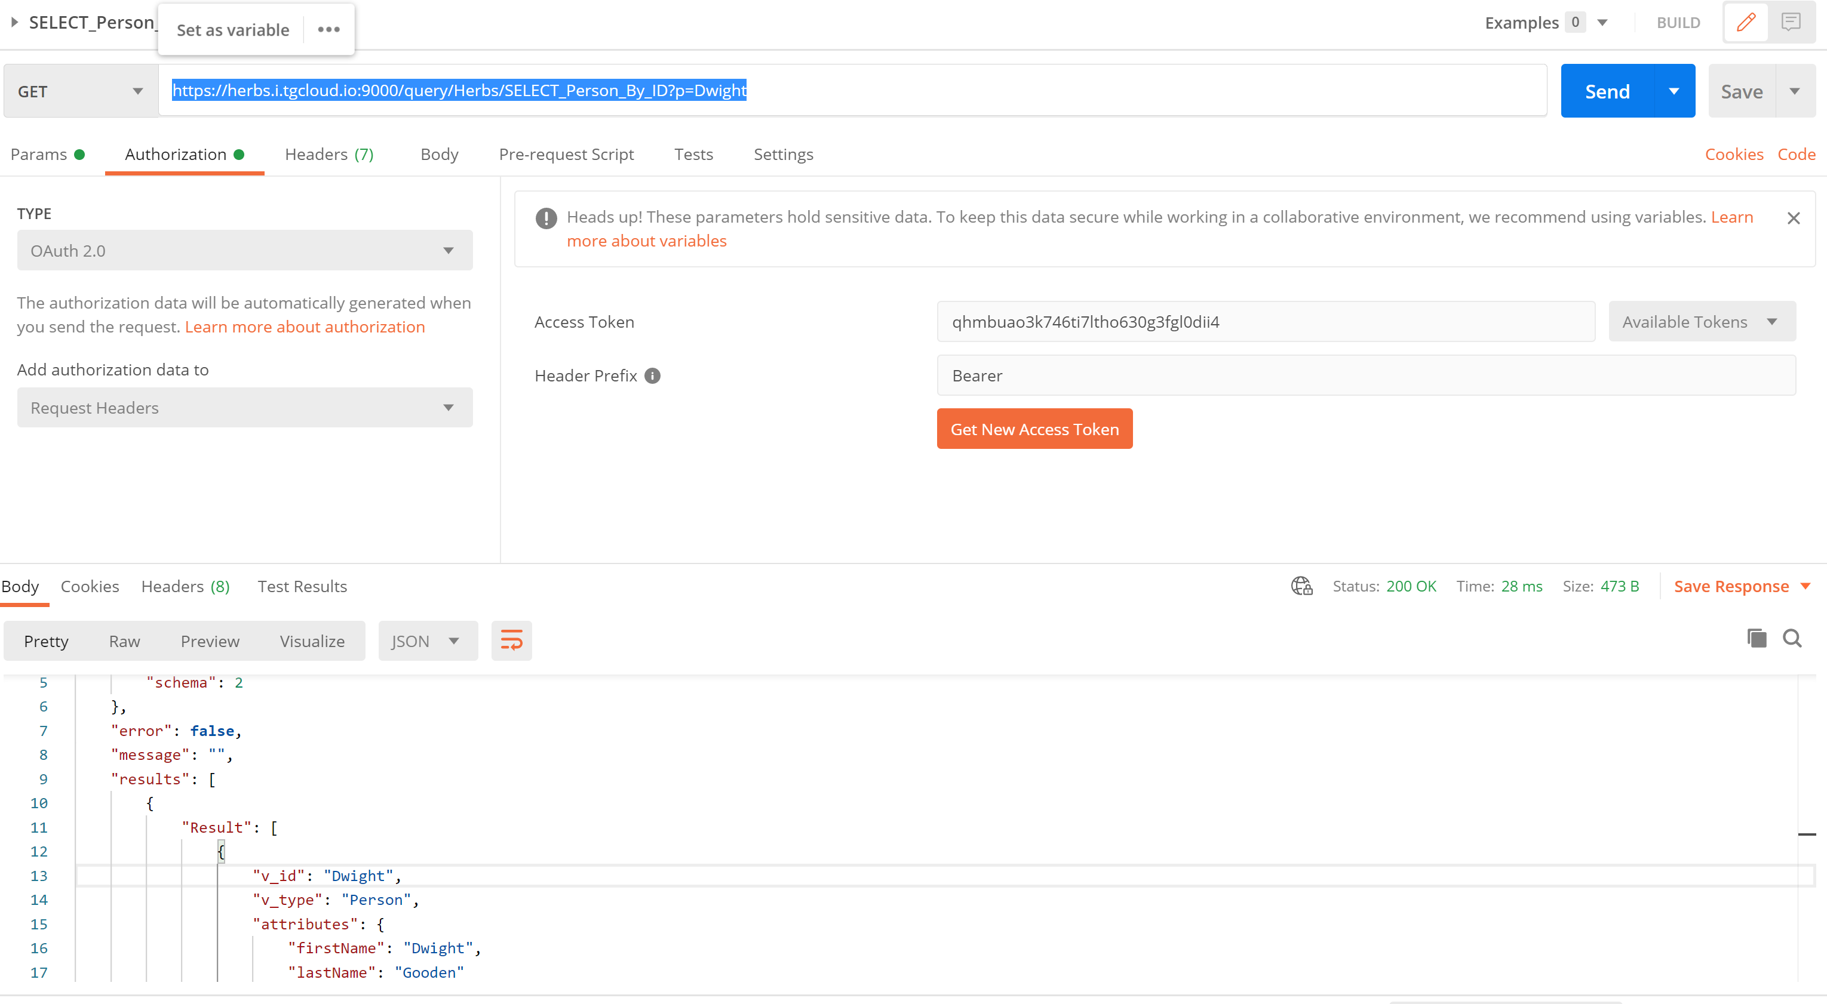

**SECTION 2**

**Fraud Graph**

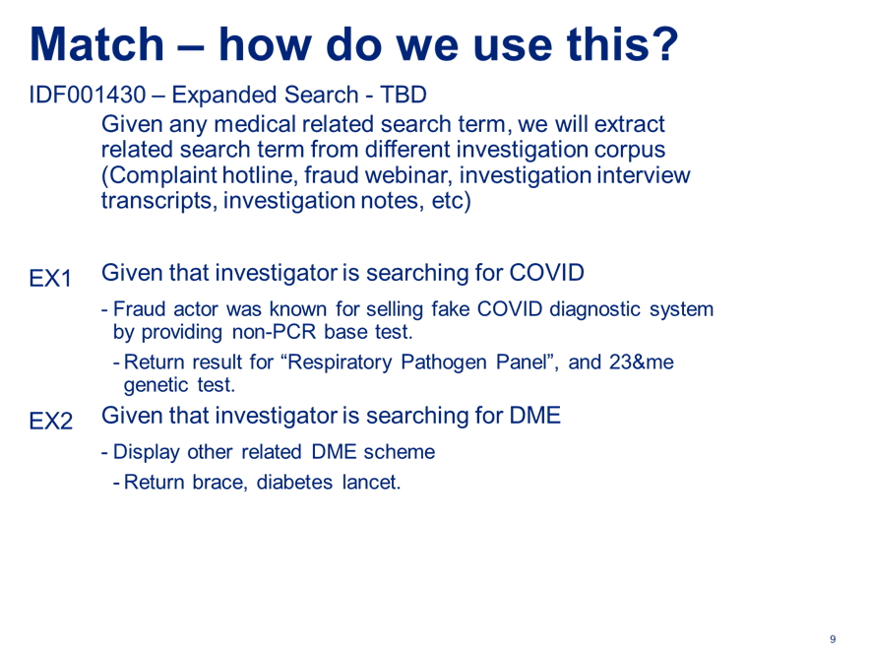

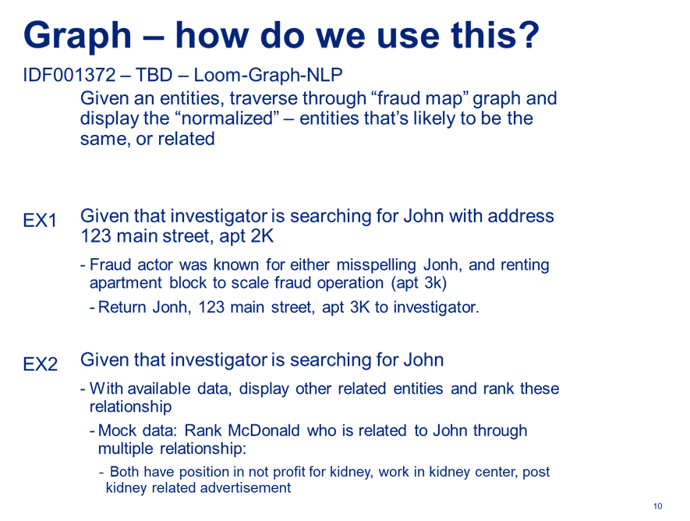

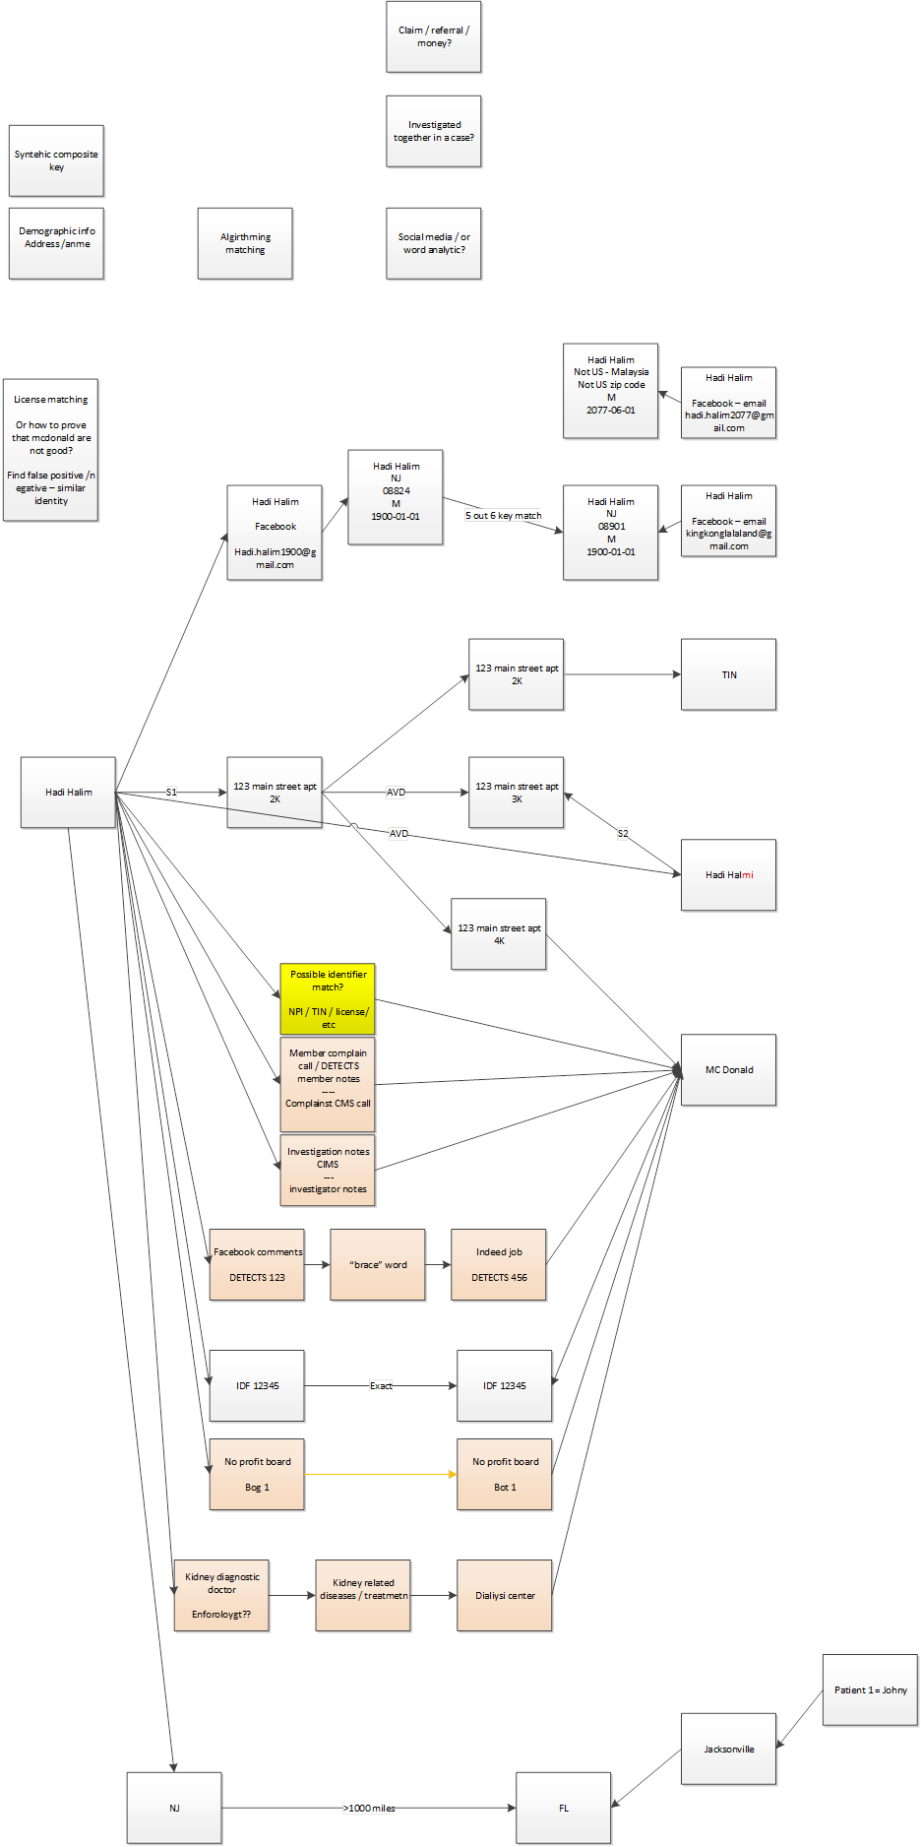

Cheers,

Hadi

* + - 1. **Create Graph**
      2. **Design Schema**

**RESOURCES**<https://towardsdatascience.com/everything-to-know-to-pass-your-tigergraph-certification-test-6c3d313c0fce>

[OFS Fraud Docs (optum.com)](https://github.optum.com/pages/ATC/OFS-Fraud-Docs/)

[IDAAT GitHub Page (optum.com)](https://github.optum.com/pages/EISSnackerDoodles/IDAAT/#/BANK)

[DGL at a Glance — DGL 0.5.3 documentation](https://docs.dgl.ai/tutorials/basics/1_first.html)

<https://atc.optum.com/solutions/projects/tpi/#trigger-point-injections>

**TO DO**<https://towardsdatascience.com/using-scispacy-for-named-entity-recognition-785389e7918d>  
<https://www.tigergraph.com/blogs/developer/linking-documents-in-a-semantic-graph-part-2/>  
<https://www.tigergraph.com/blogs/developer/graph-query-searches/>

**Data Science**

**Questions**

Providers with most number of TINs  
Ketamine – IV anesthetic  
Being prescribed off label for a bunch of other stuff (J3490)  
Use of ketamine in medically unnecessary situations

IDF (a patent term – not applicable)  
Needs ROI  
CBA

How do we spread the costs of data ingestion and modelling?

How long does it take investigators to research a case/question using existing technologies?

All drugs have an NCII number. Health plans should never see claims submitted for drug unspecified.   
Providers who are the biggest offenders of these.  
Profile of patient.

<https://atc.optum.com/solutions/projects/tpi/#trigger-point-injections>

[10:53 AM] McCreary, Dan G  
Standard algorithm is Levenshtein distance: <https://en.wikipedia.org/wiki/Levenshtein_distance>  
Levenshtein distance  
In information theory, linguistics, and computer science, the Levenshtein distance is a string metric for measuring the difference between two sequences. Informally, the Levenshtein distance between two...  
en.wikipedia.org